1  Choose an Egyptian god or goddess and create a fact file about them.  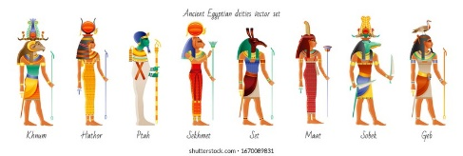 | Year 6 Homework  Autumn 1 Term  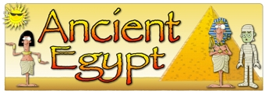 |  | 2  Create a word search or crossword about adaptation or inheritance.  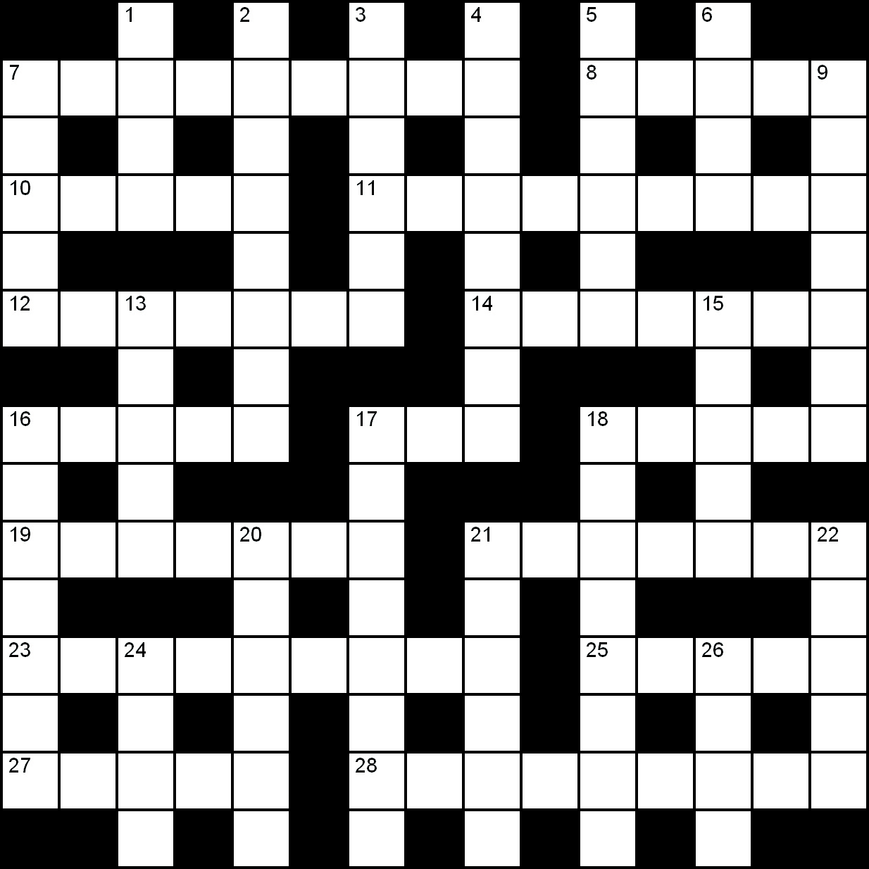
3  Write a diary entry about how you survived on a desert island.  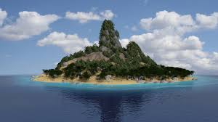 | 4  Be creative – make your own habitat scene using your own choice of materials.   | 5  Have a go at the Ancient Egyptian number sheet on SeeSaw!  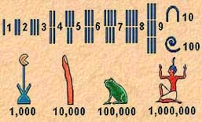 | 6  Create or draw your own tomb or coffin for a mummy. Remember they were decorated with pictures and showed the wealth of the person inside.  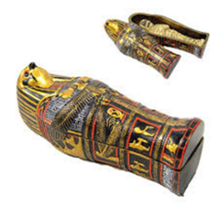
7  Design your own paschal candle for a baby’s baptism.   | 8  Draw/ create your own camouflage pattern. Can you hide an animal within your pattern?  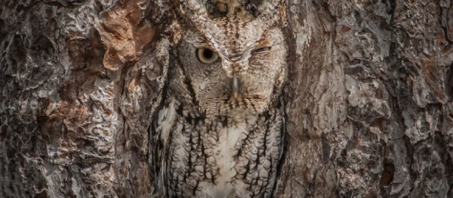 | 9  Using the word ADAPTATION, write an acrostic poem about what it means.  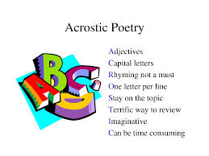 | 10  Using your senses, write a description of an underwater habitat. What can you see, hear, smell etc?  Can you show not tell? Can you use descriptive language such as similes and/ or metaphors?  

