Ribbleton Avenue Methodist Junior School



Handwriting Policy
July 2026

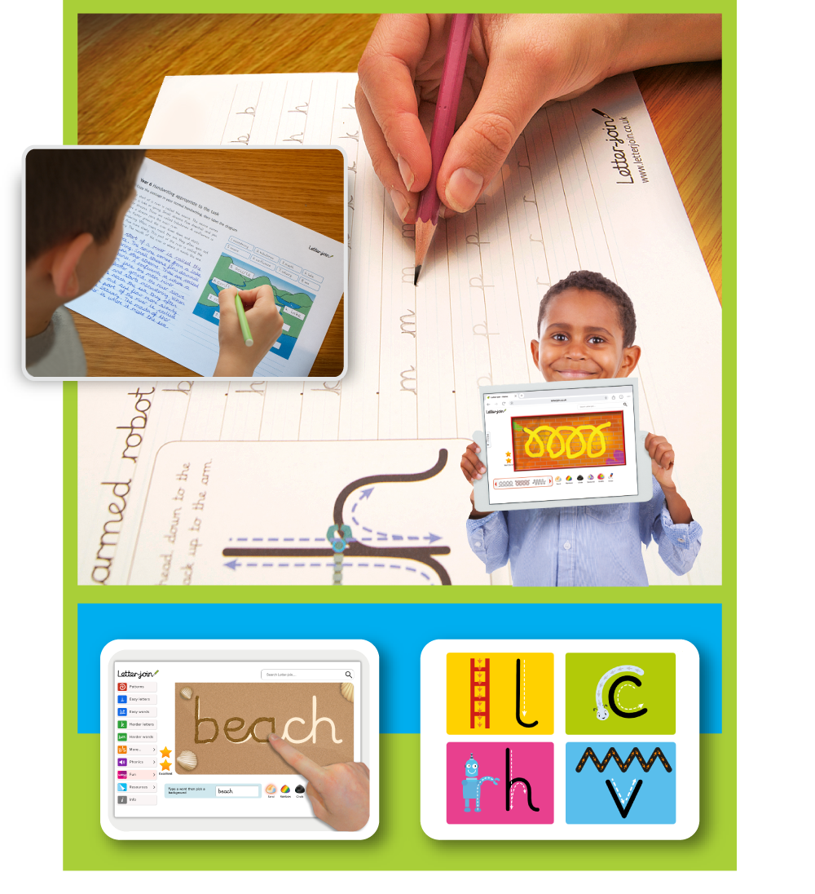

Handwriting Policy
We are very proud of our pupils’ handwriting and take particular care with our handwriting style.
In line with the Writing Framework 2025, handwriting is taught explicitly and regularly across the school beginning in reception, in addition to writing in phonics lessons. We use Letter-join’s whole school handwriting scheme as the basis of our handwriting policy, which enables us to meet National Curriculum requirements through a structured teaching programme.
Objective
Handwriting is a core skill which influences the quality of work throughout the curriculum. By the end of Key Stage 2 pupils should have the ability to produce fluent, legible and speedy joined handwriting, and to understand that different styles of handwriting are used for different purposes.
Our intention is to make handwriting an automatic process that does not interfere with creative and mental thinking.

Aims
- Develop neat, legible and speedy handwriting where letters and words are automatically produced in independent writing.
- Establish and maintain high expectations for the presentation of written work.
- Understand, by the end of Year 6, the importance of neat presentation and the need for different handwriting styles (joined, printed or capital letters) to help communicate meaning clearly.
Expectations
All teaching staff are encouraged to model the style of handwriting chosen for each year group in our school in all their handwriting, whether on whiteboards, displays or in pupils’ books.
Consistency throughout the school
Pupils should experience coherence and continuity in the teaching and learning of handwriting across all school years and be encouraged to take pride in their work. We want to help pupils enjoy learning and developing their handwriting, so they feel a sense of achievement and pride.
Handwriting frequency
Handwriting is a cross-curricular task and will be taken into consideration during all lessons. Formal teaching of handwriting will be carried out regularly and systematically to ensure key stage targets are met throughout learning, as emphasised in the 2025 Writing Framework.
Pens and pencils
Pupils will first learn to write with chunky crayons, chalk or soft pencils while developing a proper grip before exploring with large scale drawing and writing to build fine motor skills, then moving to smaller, more precise writing tools.
When their fine motor skills are established, pupils may progress to using a handwriting pen or for more competent pupils, a ballpoint pen.
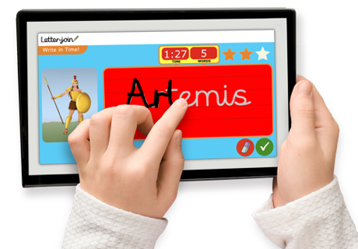
Inclusion
For children who experience handwriting difficulties due to fine motor development, including those who are left-handed and/or with special educational needs, appropriate additional support will be put in place. Letter-join’s Lesson Planners include differentiation activities for extra practice/challenge and their Handwriting Recovery Programme is used as an intervention for our key stage 2 pupils to give structured support if they find handwriting challenging.
Handwriting at home
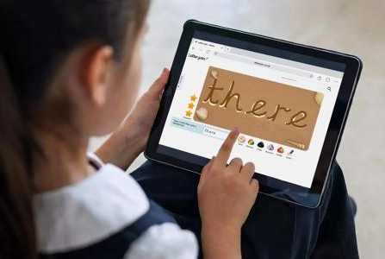
Pupils are encouraged to practise their handwriting at home using the Letter-join Pupil login.
Teachers may set Home Learning Tasks, but children can also explore Letter-join’s handwriting resources, including watching and practising letter and word animations (with parents) and playing online interactive games. Letter-join’s online games and activities include:

For pupils still working to consolidate Early Years and Key Stage 1:
- Magic Patterns - supports the development of fine motor skills through tracing patterns, shapes and mazes.
- Magic Words - gives children the freedom to practise handwriting by tracing their own choice of letters and words.
- Write it Right! - awards stars for practising and improving letter shapes and joins.
- When I Grow Up - lets learners select fun characters while learning to write their names.
- LetterMatch - helps children learn the sounds and names of letters.
- LetterLotto - rewards pupils when they correctly recognise and trace letters.
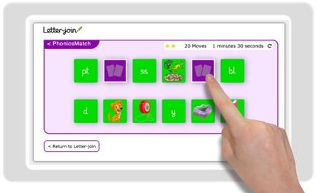
- Letter Families - is a fun activity for learning which letter family each letter of the alphabet belongs to.

Phonics:
- SoundMatch - is a fun matching pairs game exploring Phase 1 phonics sounds.
- PhonicsMatch - is a fun matching pairs game for Phases 2 to 5 phonics.
- Phozzle - gets children practising phonemes and graphemes to reveal a mystery picture.
Key Stage 2:
- Write in Time! - is a fun, timed activity to support the development of fast and fluent handwriting.
- Remember Write - helps boost spelling and writing while testing pupils’ memory skills.
All Key Stages:
- Word Bank - a bank of words created by a teacher to support the learning of spelling and vocabulary for pupils to practise.
- Word Search - pupils have fun finding words while learning tricky spellings.
- Spelling lists - pupils practise high frequency, common exception and statutory words.

RAMJS Pre KS2 Teaching
Emergent writers – consolidating EYFS
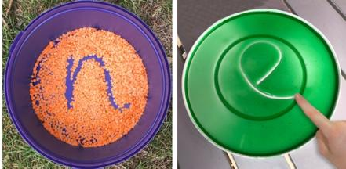
We teach short, daily handwriting lessons, which may include:
- warm-up activities to get ready for handwriting
- air writing, pattern making and physical activities to develop gross motor skills
- correct sitting position and pencil grip for writing
- mark making on paper, whiteboards, sensory trays and tablets, etc. to develop and refine fine motor skills
- the introduction of letter shapes, their sounds, formation and vocabulary.

Module 1 Lesson Planner
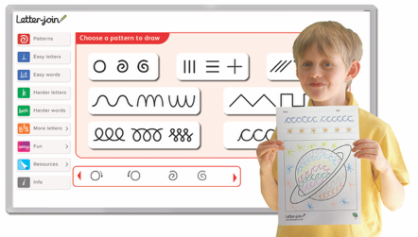
*Delete Print or Cursive section accordingly.
*Module 1 Print teaches handwriting using a printed font style.
This module is divided into three sections covering:
- pre-writing patterns
- easy letters and words
- harder letters and words.
At the end of this module children should be able to recognise and form all lowercase letters of the alphabet in a printed style.

*Module 1 Cursive teaches pre-writing patterns and cursive letters.
This module is divided into three sections covering:
- pre-writing patterns
- easy letters and words
- harder letters and words.
At the end of this module children should be able to recognise and form all lowercase letters of the alphabet in a cursive style.
They should know how to write words using the correct joining techniques (unless using a pre-cursive font for learning letter shapes).

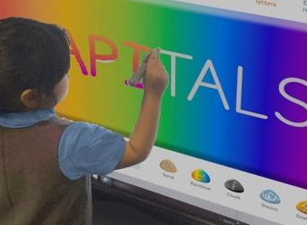
RAMJS Developing writing working to consolidate Key Stage 1: Years 1 and 2
Teaching progresses from five short lessons to three longer lessons per week:
- continuing with gross and fine motor skills activities
- practise to strengthening handwriting learning
- learning where and when to use capitals and printed letters, reinforced by practice
- practising handwriting with spelling, punctuation and grammar (SPaG).

Module 2 Lesson Planner: Year 1
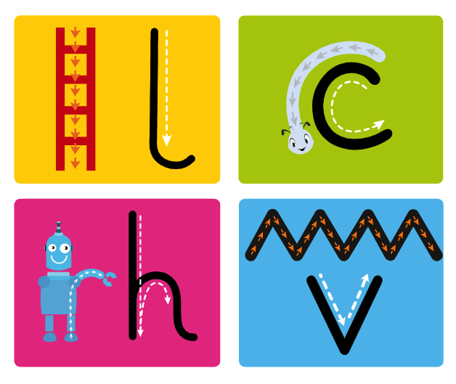
*Delete Print or Cursive section accordingly.
*Module 2 Print to Cursive teaches how to correctly use and write capital letters, printed letters, numbers, punctuation, maths symbols and other symbols. Children are then introduced to pre-writing patterns and cursive letters in preparation for Module 3 when they are required to start joining their handwriting.
This module is divided into three sections covering:
- warm-up activities, letter families and capital letters
- the uses of printed letters
- numbers and symbols
- the introduction of pre-cursive patterns and cursive letters.
On completion of this module, children should be confident in writing all capital and printed letters, numbers and symbols and have some familiarity with the orientation of cursive letters.

*Module 2 Cursive teaches how to write capital letters, printed letters, numbers and symbols, whilst reinforcing joined handwriting using Letter-join’s resources.
This module is divided into three sections covering:
- warm-up activities, letter families and capital letters
- the uses of printed letters
- numbers and symbols.
On completion of this module, children should be confident in writing all capital and printed letters, numbers and symbols and start to become familiar with their use.

Module 3 Lesson Planner: Year 2
*Delete Print or Cursive section accordingly.
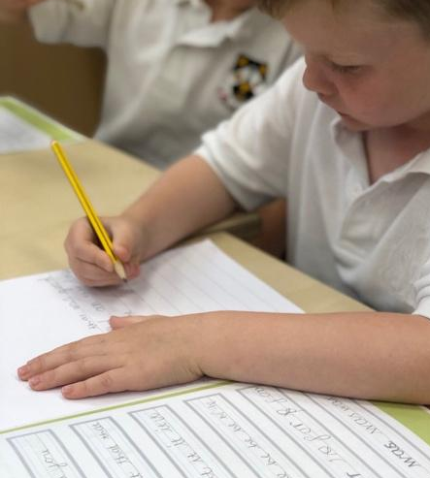
*Module 3 Starting Cursive introduces children to cursive letters and how to join them which is reinforced with regular practice in letter formation and joining.
The sections in this module cover:
- cursive letters and words
- revisiting letter families
- high frequency words
- joining techniques
- sequencing sentences
- dictation exercises
- times table facts
- spelling, punctuation and grammar (SPaG) practice.
With regular handwriting practice throughout this module, children should now be developing fluency and speed in their writing.

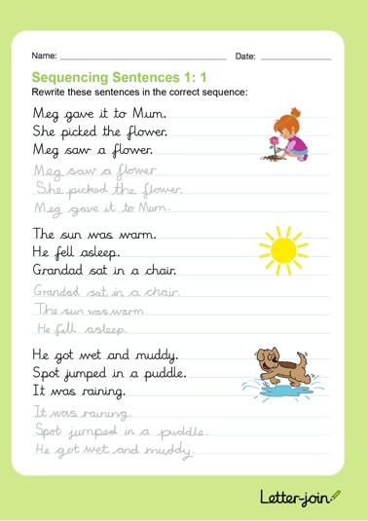
*Module 3 Cursive includes lessons to improve letter formation and orientation through regular practice supporting spelling, punctuation and grammar (SPaG).
The sections in this module cover:
- letter families
- high frequency words
- joining techniques
- sequencing sentences
- dictation exercises
- times table facts
- spelling, punctuation and grammar (SPaG) practice.
With regular handwriting practice throughout this module, children should now be developing fluency and speed of their writing.
RAMJS Lower Key Stage 2: Years 3 and 4
Handwriting lessons will continue twice a week in Lower Key Stage 2.
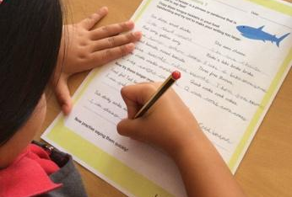
Module 4 Lesson Planner: Year 3
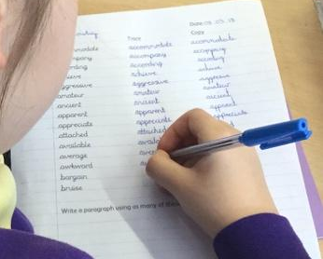
Module 4 teaches pupils to use a joined style throughout their independent writing in all subjects, helping them to refine their handwriting based on the requirements of each lesson. This module covers topics such as dictation, double letters, number vocabulary, palindromes, tongue twisters, modern foreign languages (French and Spanish), onomatopoeia, simile and statutory spellings.
Through a variety of resources which link handwriting to other areas of the curriculum, on completion of this module, the legibility, consistency and quality of handwriting should be improving.

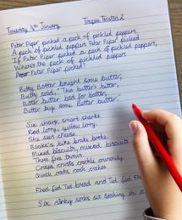
Module 5 Lesson Planner: Year 4
Module 5 focuses on handwriting practice which supports other subjects in the curriculum and, at the same time, builds on fluency and consistency. This module aims to promote meaningful links with other subjects such as English, maths, science, geography, French and Spanish. Making such links enables children to apply the skills they are learning in context and, also provides depth to the curriculum.
Learners will continue to build on producing fluent, consistent and legible handwriting through the regular practice offered in this module’s lessons.
On concluding this module, children will have practised applying size-appropriate handwriting to all areas of the curriculum whilst maintaining fluency and legibility.
RAMJS Upper Key Stage 2: Years 5 and 6
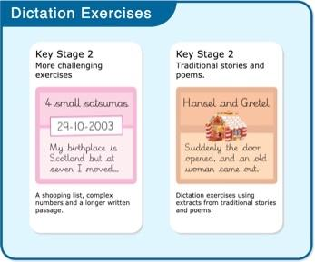
More advanced handwriting techniques will be taught during two weekly lessons:
- reinforcing joined handwriting across the curriculum
- form-filling/labelling using printed and capital letters
- dictation exercises promoting quick note-taking and speedy handwriting writing skills
- SATs spelling, punctuation and grammar (SPaG) practice.

Module 6 Lesson Planner: Year 5

Module 6 continues to build on combining fluent handwriting with other subjects across the curriculum.
In this module, learners will have plenty of opportunity to develop the skills and stamina needed to write at length, with accurate spelling and punctuation. With Letter-join’s wide range of resources they will be able to work towards producing consistently neat and well-presented handwriting in all curriculum subjects.
On completing this module, children should be producing joined writing automatically, enabling them to focus on the content of their work rather than the process of writing.

Module 7 Lesson Planner: Year 6
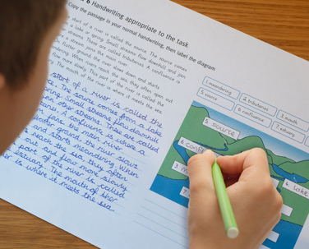
Module 7 presents learners with a range of tasks where they need to decide on an appropriate style of handwriting. Promoting speedy, fluent writing continues to be a strong feature. Challenging dictation exercises help refine pupils’ revising and checking skills as well as boosting their handwriting speed, stamina and fluency. A range of curriculum-based worksheets offer opportunities to practise writing at length.
Module 7 also contains a series of worksheets to support SATs SPaG revision. They are designed to support pupils in meeting expected standards for spelling, punctuation and grammar, with lots of SPaG preparation and plenty of handwriting practice.
By the end of this module, children should be able to adapt their handwriting for a range of tasks and purposes and to create different effects and styles. They should be clear about what standard of handwriting is appropriate for a particular task, for example, quick notes, a final handwritten version, capital letters or an unjoined style.
Correct posture, pencil grip and paper position for handwriting
Pupils are taught to sit correctly at a table and hold a pencil comfortably and correctly.

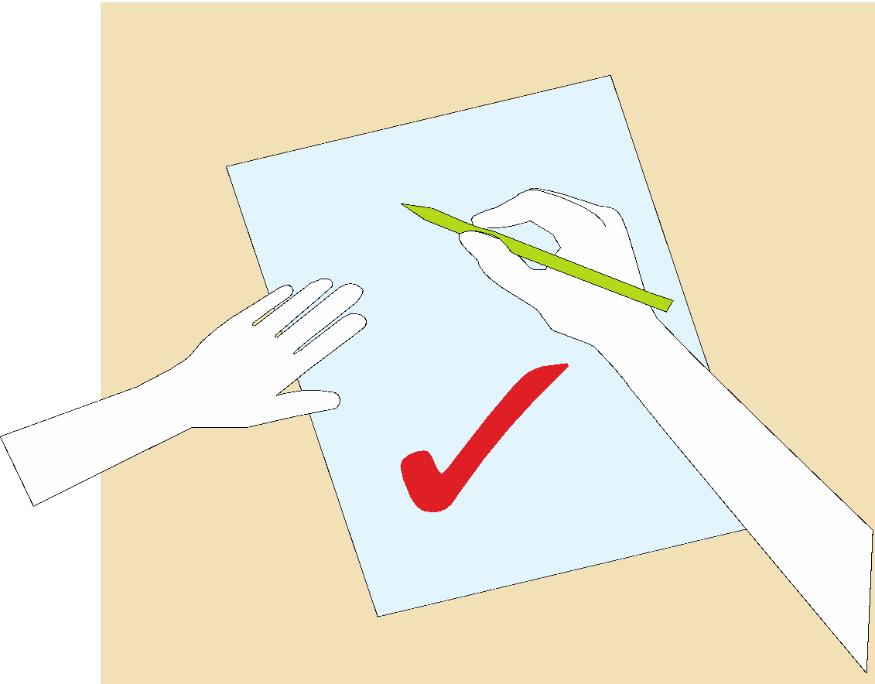
Sitting position
Sit with a straight back, not leaning over the page.
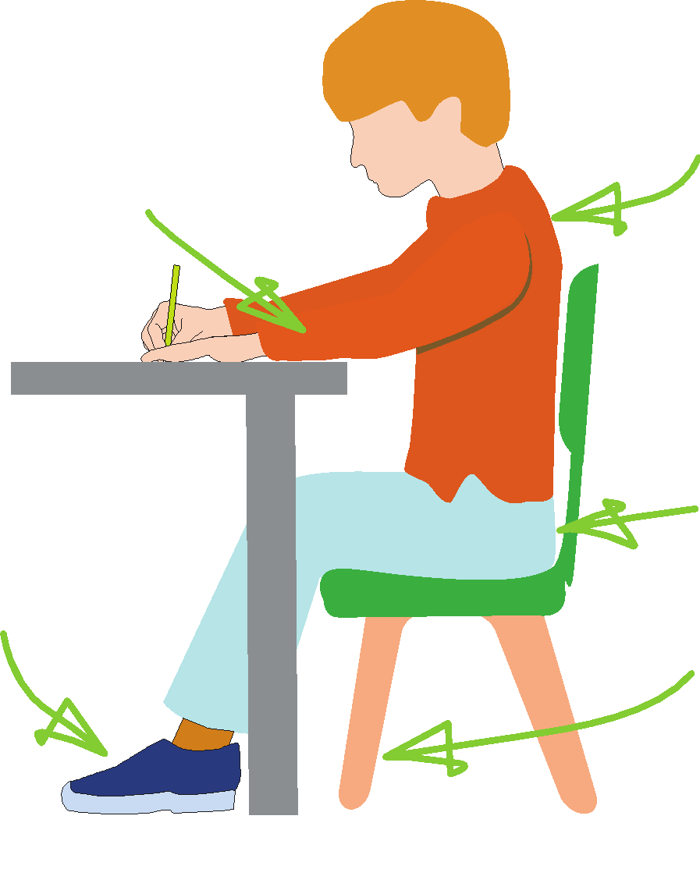
Sit right back in the seat.
The table reaches to below the elbow.

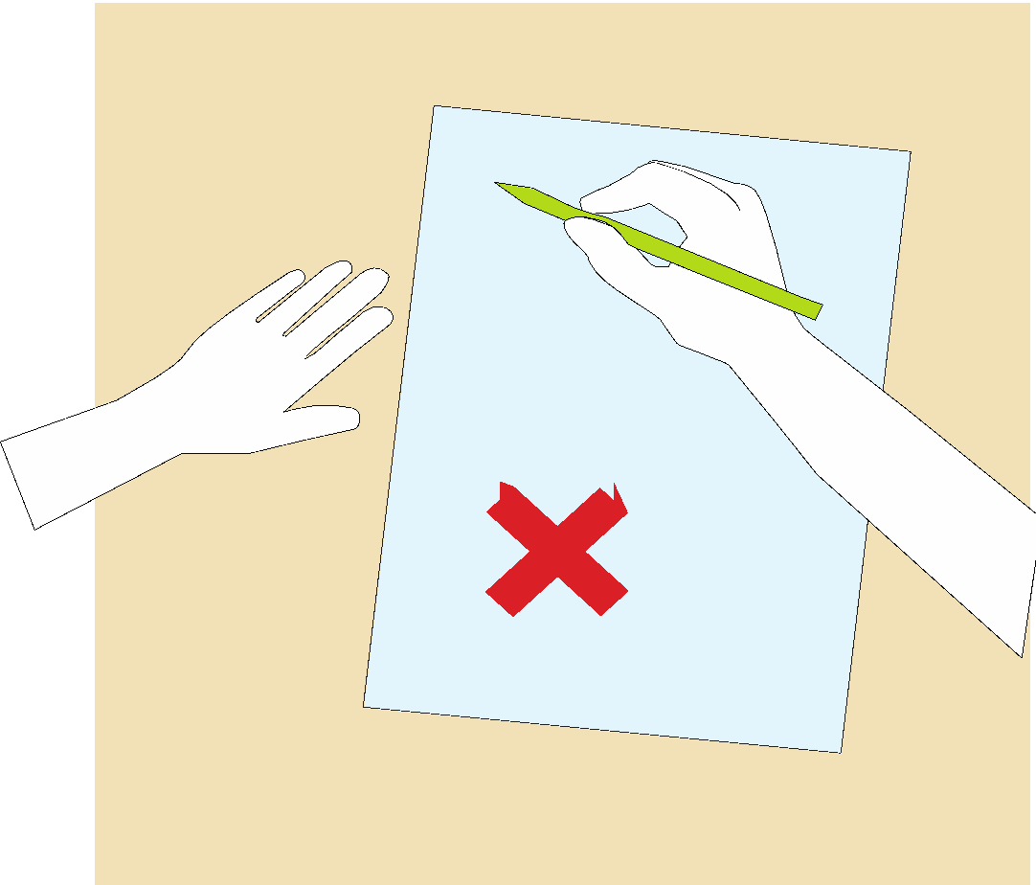
Keep feet flat on the floor.
Pull the chair close to the table.
Right-handed paper position.

Left-handed writer
Left-handed children may find it difficult to follow the movements of right-handed teachers as they model letter formation (and vice versa). Teachers will demonstrate to left-handers on an individual or group basis.
- Left-handed pupils should sit to the left of a right-handed child so that they are not competing for space.
- Pupils should position the paper/book to their left side and slanted, as shown.
- Pencils should not be held too close to the point as this can interrupt pupils’ line of vision.
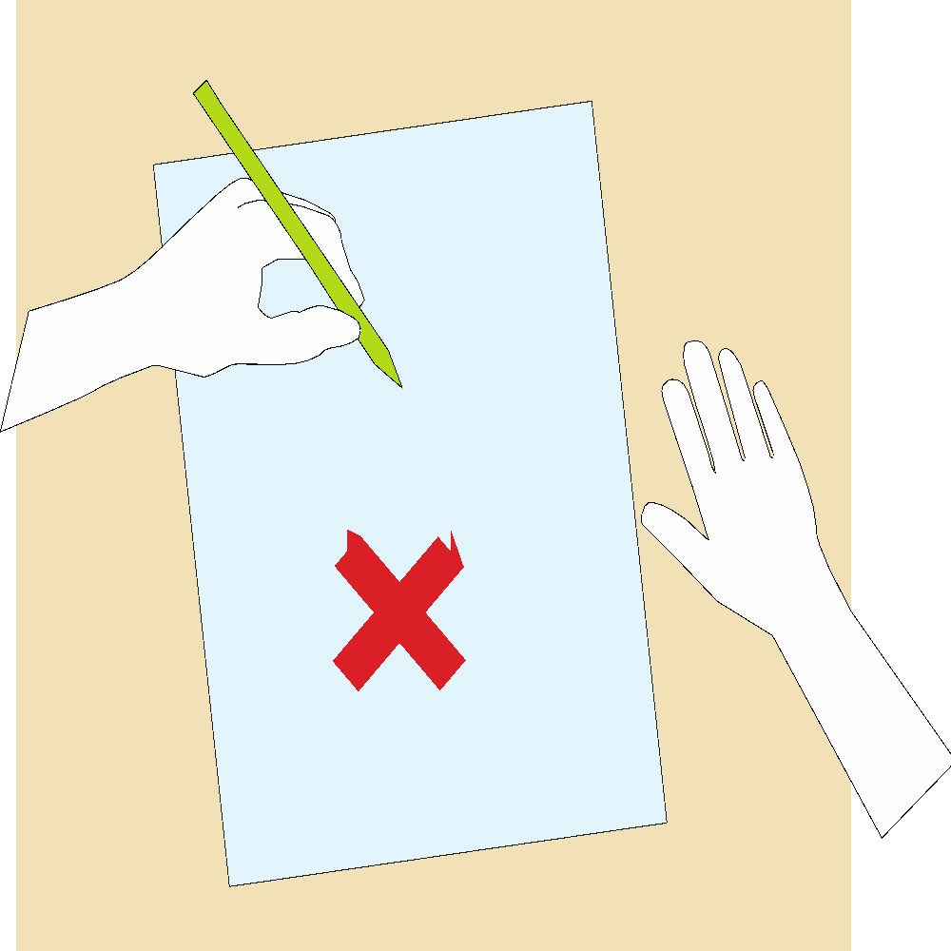



- Extra practice with left-to-right exercises may be necessary before pupils write left-to-right automatically.

Left-handed paper position.

The Tripod Pencil Grip
Both right and left-handed children should use the tripod grip which enables the pen/pencil to be held securely whilst allowing controlled movements of the pen/pencil nib.
We use the Tripod Grip rhyme:
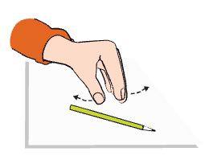
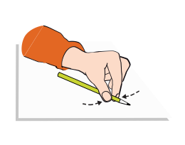
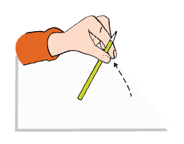
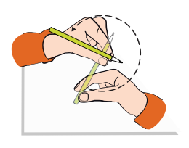
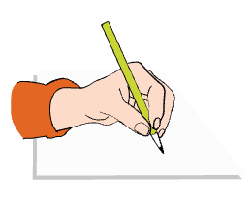

Point away the pencil, Pinch it near the tip, Lift if off the table, Spin it round... and grip.
Point away the pencil, Pinch it near the tip, Lift if off the table, Spin it round... and grip.
Right-handed pencil grip
Left-handed pencil grip

