INTENT:
At RAMJS we want pupils to be MASTERS of technology and not slaves to it. Technology is everywhere and will play a pivotal part in students' lives. Therefore, we want to model and educate our pupils on how to use technology positively, responsibly and safely. At RAMJS we view computing as an integral component of the curriculum. We want our pupils to be creators not consumers and our broad curriculum encompassing computer science, information technology and digital literacy reflects this. We want our pupils to understand that there is always a choice with using technology and as a school we utilise technology to model positive use. We recognise that the best prevention for a lot of issues we currently see with technology/social media is through education. We recognise that technology can allow pupils to share their learning in creative ways. We also understand the accessibility opportunities technology can provide for our pupils. Our knowledge rich curriculum has to be balanced with the opportunity for pupils to apply their knowledge creatively which will in turn help our pupils become skilful computer scientists. We encourage staff to try and embed computing across the whole curriculum to make learning creative and accessible. We want our pupils to be fluent with a range of tools to best express their understanding and hope by Upper Key Stage 2, children have the independence and confidence to choose the best tool to fulfil the task and challenge set by teachers. Computing capability is an essential skill for life and enables learners to participate more readily in a rapidly changing world. Using the internet, social media and email, for example, gives them rapid access to ideas and experiences from a wide range of people, communities and cultures. Our curriculum has been designed to ensure learners have sufficient knowledge to stay safe online and use computers safely in life. Learners have the opportunity to develop their capability, creativity and knowledge in computer science, digital media and information technology. Our overall aim is to enhance learning in all areas of the curriculum through the use of computing. In particular, children should achieve the following skills and abilities:
- to become confident in handling hardware, software and other computing equipment;
- to develop their basic coding skills and subject specific vocabulary;
- to develop the ability to use computing equipment to manipulate and present written word, images and sounds so as to convey a message effectively;
- to be able to use computing equipment to store information, retrieve and then present it in ways that enhance interpretation and analysis;
- to begin to understand the role of computing encountered in daily life to monitor and control events and equipment;
- to use appropriate hardware and software creatively when engaged in basic tasks such as coding activities
- to apply their computing skills and knowledge to their learning in other areas;
- to use their computing skills to develop their language and communication skills;
- to explore their attitudes towards computing and its value to them and society in general.

IMPLEMENTATION
We have created a comprehensive progression document for staff to follow to best embed and cover every element of the computing curriculum. The knowledge/skills statements build year on year to deepen and challenge our learners.
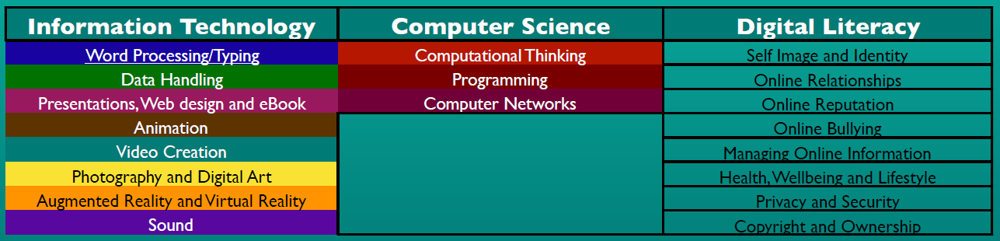
At RAMJS we feel the majority of computing should be embedded across the curriculum. Classes will be timetabled to a Computing session each week. The timetabled computing session will focus on one of two elements: An Explicit Computer Science lesson or A Tinkering Session. The computer science part of the computing curriculum will often, but not always, need a more explicit approach. That is not to say it can’t be embedded across the curriculum. A tinkering session looks at introducing a new app or tool and giving children opportunity to experiment and familiarise themselves with the different elements and tools before it can be applied in a more focused approach across the curriculum. This way computing is embedded to allow learning to be more accessible and allow learners to be more creative in demonstrating their learning.
IMPACT
We encourage our children to enjoy and value the curriculum we deliver. We will constantly ask the WHY behind their learning and not just the HOW. We want learners to discuss, reflect and appreciate the impact computing has on their learning, development and well being. Finding the right balance with technology is key to an effective education and a healthy life-style. We feel the way we implement computing helps children realise the need for the right balance and one they can continue to build on in their next stage of education and beyond. We encourage regular discussions between staff and pupils to best embed and understand this. The way pupils showcase, share, celebrate and publish their work will best show the impact of our curriculum. We also look for evidence through reviewing pupil’s knowledge and skills digitally through tools like Seesaw and observing learning regularly. Progress of our computing curriculum is demonstrated through outcomes and the record of coverage in the process of achieving these outcomes.

COMPUTING NATIONAL CURRICULUM

Purpose of study
Our computing curriculum equips pupils to use computational thinking and creativity to understand and change the world. Computing has deep links with mathematics, science and design and technology, and provides insights into both natural and artificial systems. Children are taught the principles of information and computation, how digital systems work and how to put this knowledge to use through programming. Building on this knowledge and understanding, children are equipped to use information technology to create programs, systems and a range of content. Computing also ensures that pupils become digitally literate – able to use, and express themselves and develop their ideas through, information and communication technology – at a level suitable for the future workplace and as active participants in a digital world.

Aims
The national curriculum for computing aims to ensure that all pupils:
- can understand and apply the fundamental principles and concepts of computer science, including abstraction, logic, algorithms and data representation
- can analyse problems in computational terms, and have repeated practical experience of writing computer programs in order to solve such problems
- can evaluate and apply information technology, including new or unfamiliar technologies, analytically to solve problems
- are responsible, competent, confident and creative users of information and communication technology

Attainment targets
By the end of each key stage, pupils are expected to know, apply and understand the matters, skills and processes specified in the relevant programme of study.

Key stage 2
Pupils should be taught to:
- design, write and debug programs that accomplish specific goals, including controlling or simulating physical systems; solve problems by decomposing them into smaller parts
- use sequence, selection, and repetition in programs; work with variables and various forms of input and output
- use logical reasoning to explain how some simple algorithms work and to detect and correct errors in algorithms and programs
- understand computer networks, including the internet; how they can provide multiple services, such as the World Wide Web, and the opportunities they offer for communication and collaboration
- use search technologies effectively, appreciate how results are selected and ranked, and be discerning in evaluating digital content
- select, use and combine a variety of software (including internet services) on a range of digital devices to design and create a range of programs, systems and content that accomplish given goals, including collecting, analysing, evaluating and presenting data and information
- use technology safely, respectfully and responsibly; recognise acceptable/unacceptable behaviour; identify a range of ways to report concerns about content and contact

