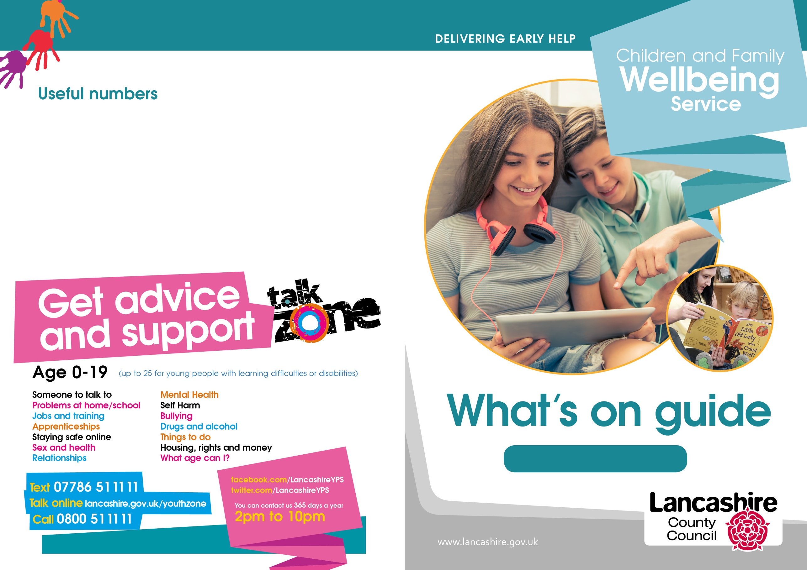
Citizens Advice Bureau: 0300 3301172
Community Midwives: 01772 524496
Family Information Services: 0300 1236712
Gateway Housing: 0800 9530213
Health Visitors: 03002470040
Job Centre Plus: 0845 6043719
Preston City Council: 01772 906907
Tax Credits: 0345 3003900
Children's Social Care: 0300 1236720

Preston

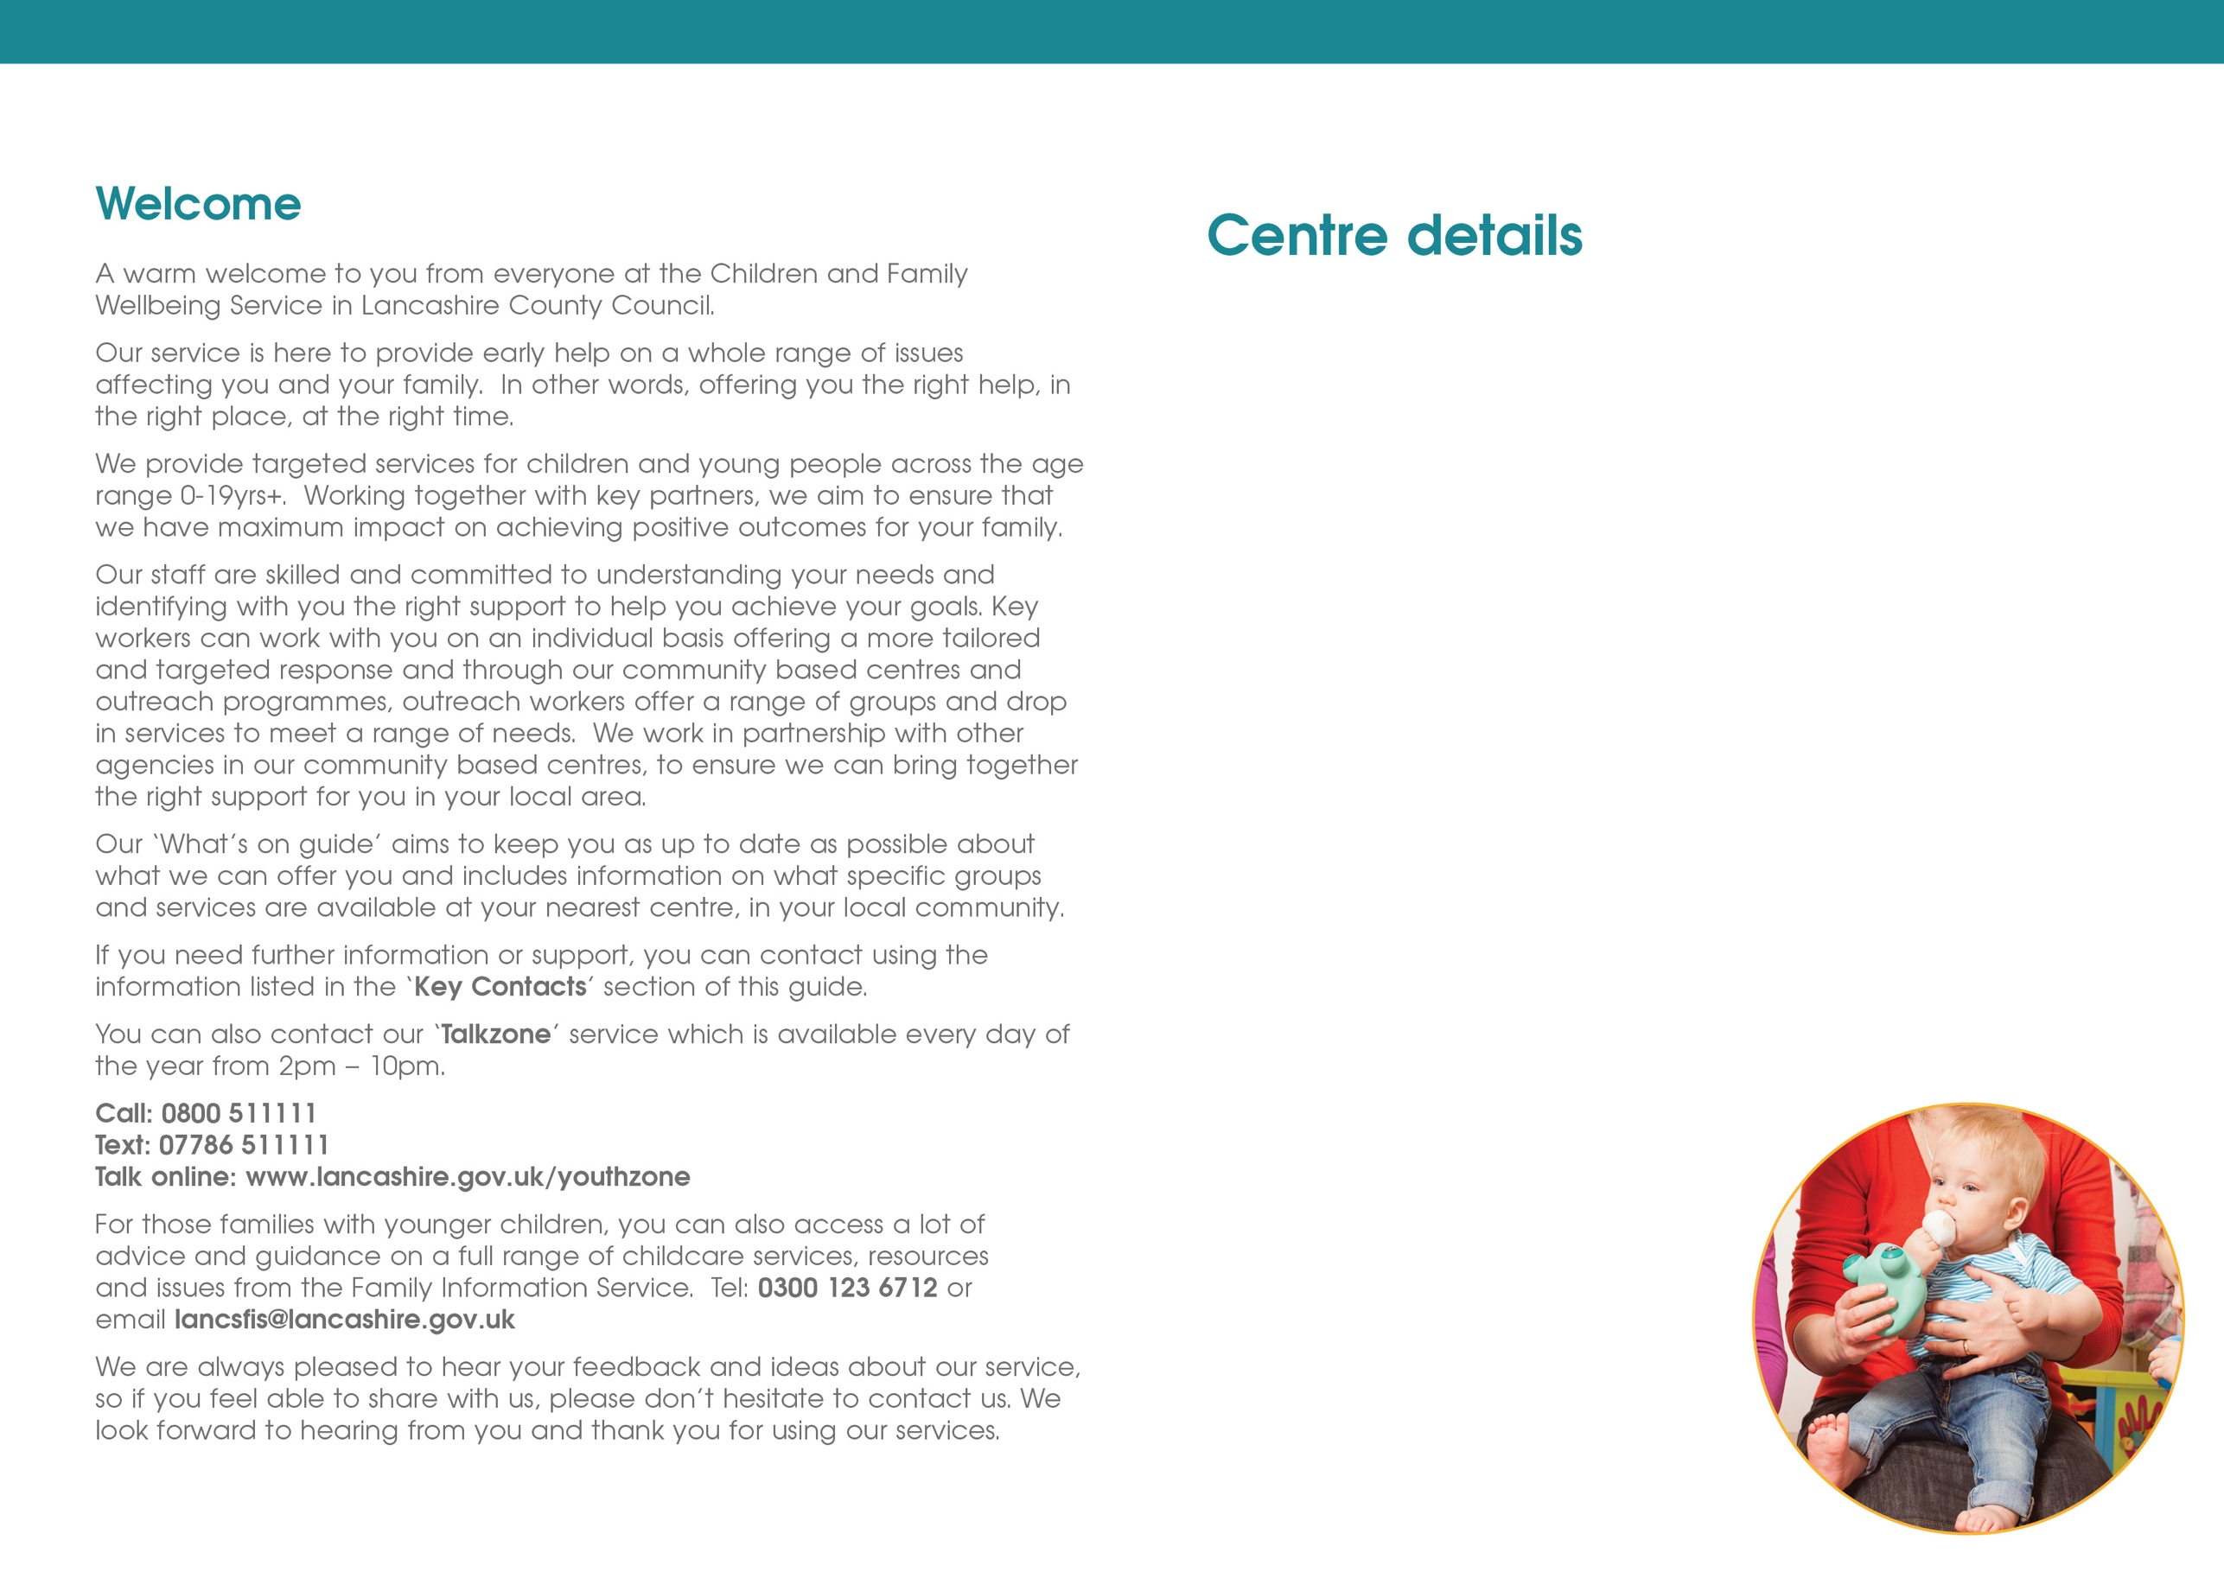
Ribbleton CFW Services
Ribbleton Hall Drive
Ribbleton
Preston
PR2 6EE
Telephone: 01772 539444

Stoneygate CFW Services
Lennox Street
Preston
PR1 3XU
Telephone: 01772 537898
Moor Nook CFW Services
Burholme Road
Ribbleton
Preston
PR2 6HN
Telephone: 01772 539460

Preston Central Neighbourhood Centre
Brieryfield Road
Preston
PR1 8SR
Telephone: 01772 531948

Preston East CFW Services
Brookfield Primary School
Watling Street Road
Preston
PR2 6TU
Telephone: 01772 539420

Preston West CFW Services
Ashton Primary School
Ainsdale Drive
Ashton-on-Ribble
Preston
PR2 1TU
Telephone: 01772 536410
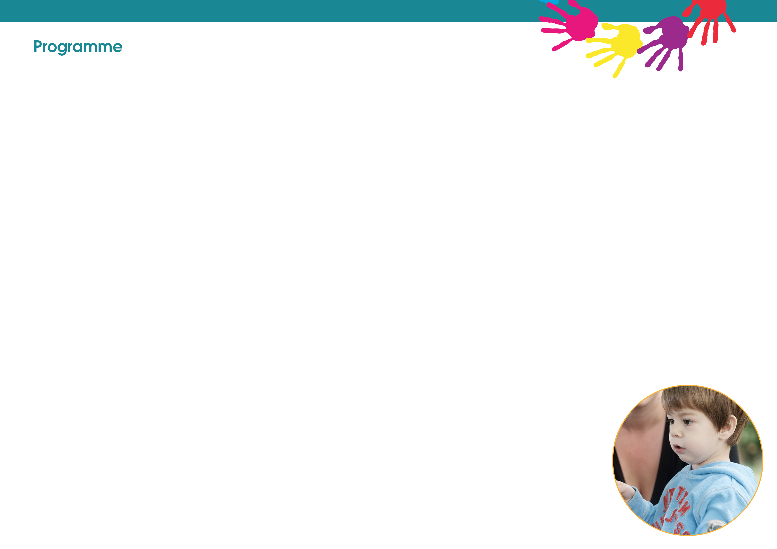

Wednesday

Stepping Stones Triple p
10:30 – 11:30am
Via Zoom

7up junior session
8-11years
4:00 - 4:45pm
Via Zoom

Tuesday

Triple P 0-12 years
10:30 am - 11:30am
Via Zoom

Let's Talk
Chat Play and Read
1:00 – 2:00pm
Via Zoom

Nurture Group
4:00pm – 4:45pm
Via Zoom
Invite only

Parents 2 Be antenatal
CFW session
2nd and 3rd Tuesday of each month
6:00 – 7:00
Via Zoom

Youth Council
6:30pm- 7:30pm
Via Zoom

Monday

Stepping Stones Triple p
10:30 – 11:30am
Ribbleton neighbourhood centre

Triple p 0-12 years
6:00-7:00pm
Via Zoom

Please ring to register your interest and details of how to log into the group
01772 539444

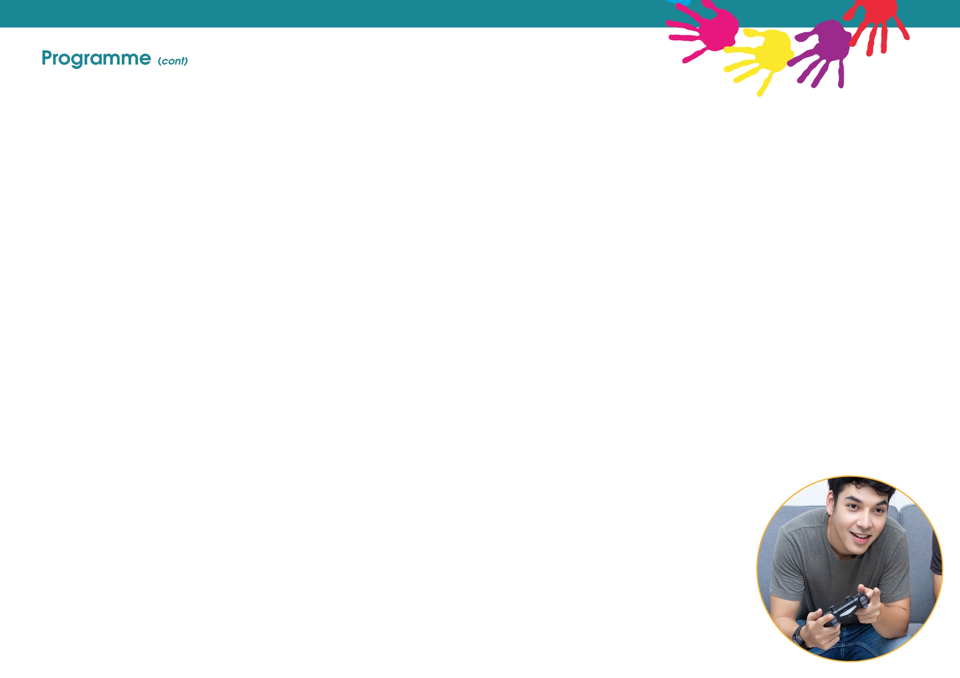
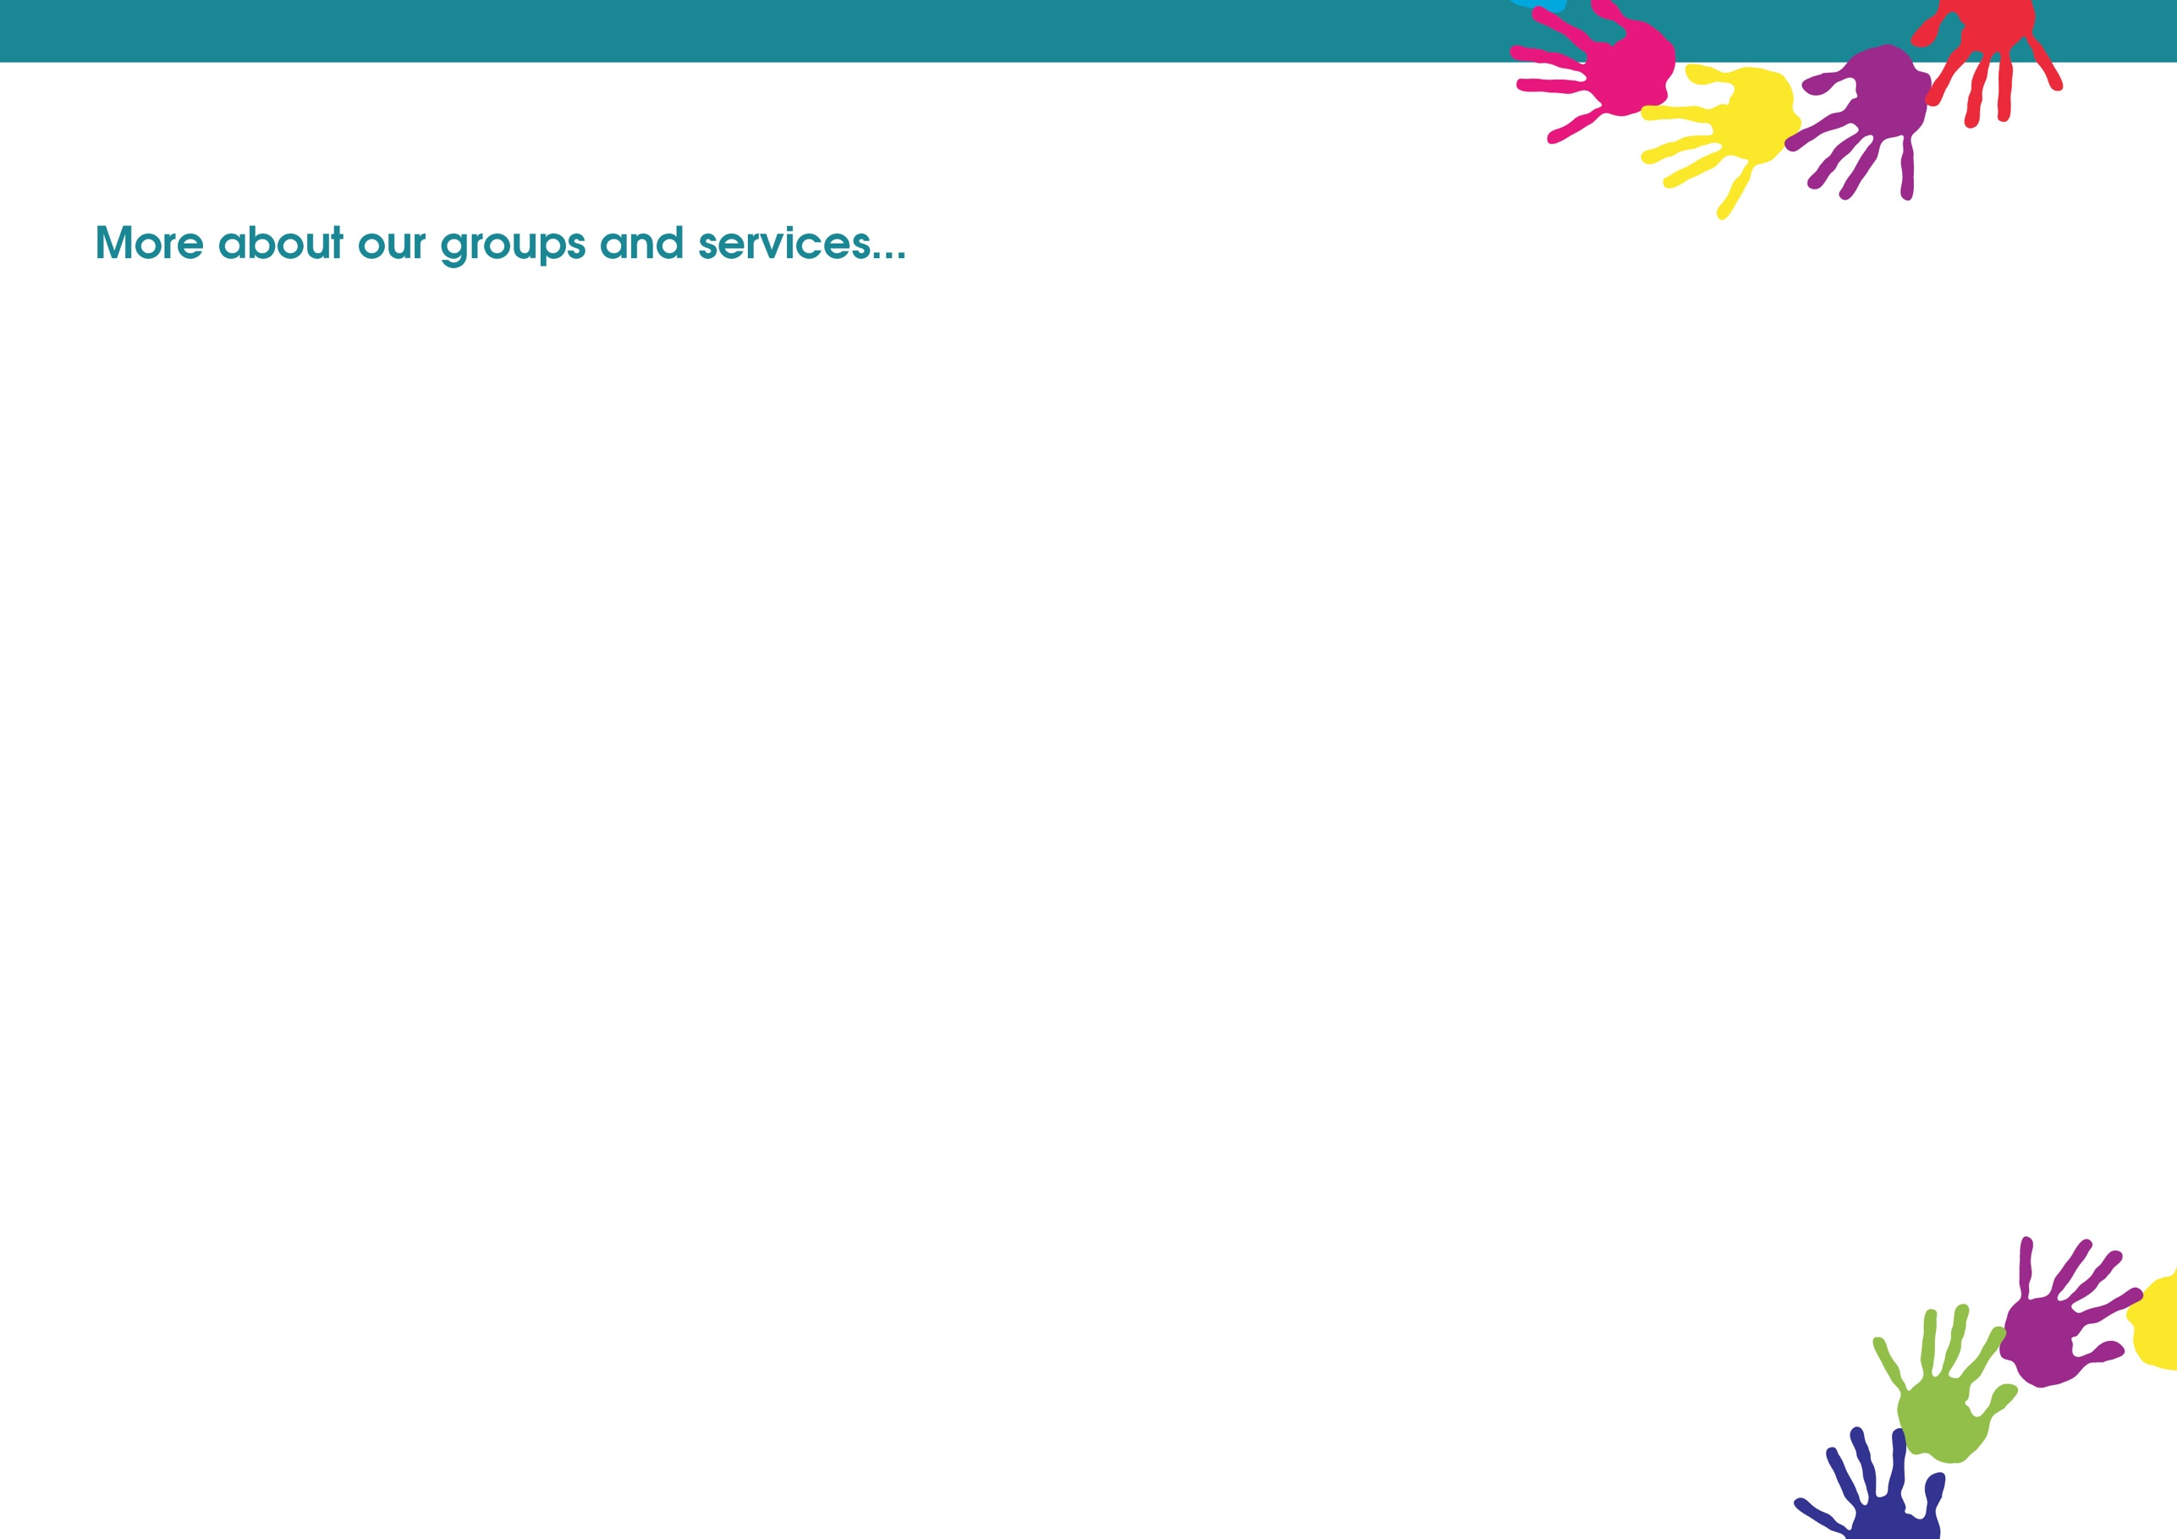

Thursday

Baby massage
10:30 – 11:30am
Via Zoom
Invite only

Nurture Group
4:00pm – 4:45pm
Via Zoom
Invite only

Friday

Triple P 0-12 years
10:30 – 11:30am
Via Zoom

Preston and South Ribble Youth Session
6:30pm – 7:30pm
Via Zoom

We are now running

The Freedom course
Please contact the centre for further details

Coming soon
Keep an eye out for any new sessions we develop over the next few months.

Please check our Facebook page for regular updates and session changes.


Preston Family Zone
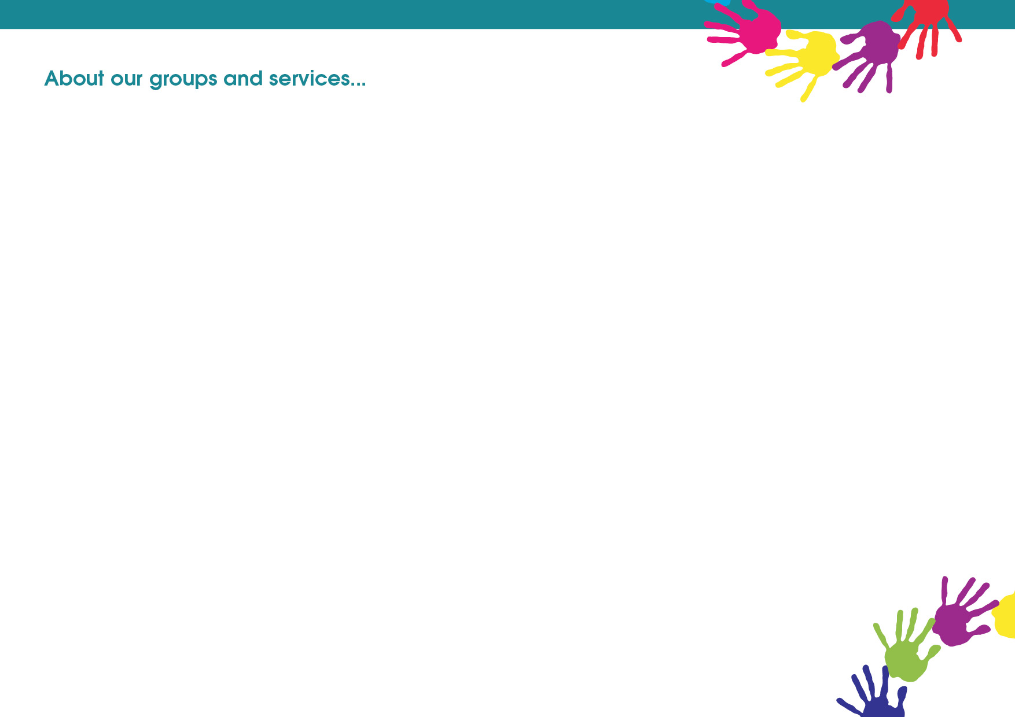

Triple P: is a parenting programme, but it doesn’t tell you how to be a parent! It's more like a toolbox of ideas. You choose the strategies that you need. You choose the way you want to use them. It's all about making Triple P work for you. The three P's stand for Positive Parenting Programme; which means your family life is going to be much more enjoyable. Please contact your local centre to find out more about Triple P and for details of the support that is available.

Let's Talk
Chat Play and Read : Delivered over 5 weeks these sessions will help your child's speech development at the same time as giving you tools to help you to continue to develop their speech at home. This group is aimed at children who are 2years old where parents are concerned about their child's speech development.

Baby Massage: birth to crawling, to promote nurturing touch and communication. Please bring a towel with you!

Parent 2 Be: is an antenatal course that is run in partnership with the Children and Family Wellbeing Service, Midwives and Health Visitors. During COVID 19 the Children and Family Wellbeing service are delivering our session online. It supports parents to be through pregnancy and beyond. The programme provides you with relevant information and key messages about infant feeding, safer sleep, play, communication and taking care of your new baby.

Currently most of our groups are being delivered Via Zoom. You will need internet connection but do not need to download any apps to join in. An invite will be sent to you before the start of the session giving instructions of how to join. Please ring the main centre number if you need further details or would like to attend a session.
01772 539444

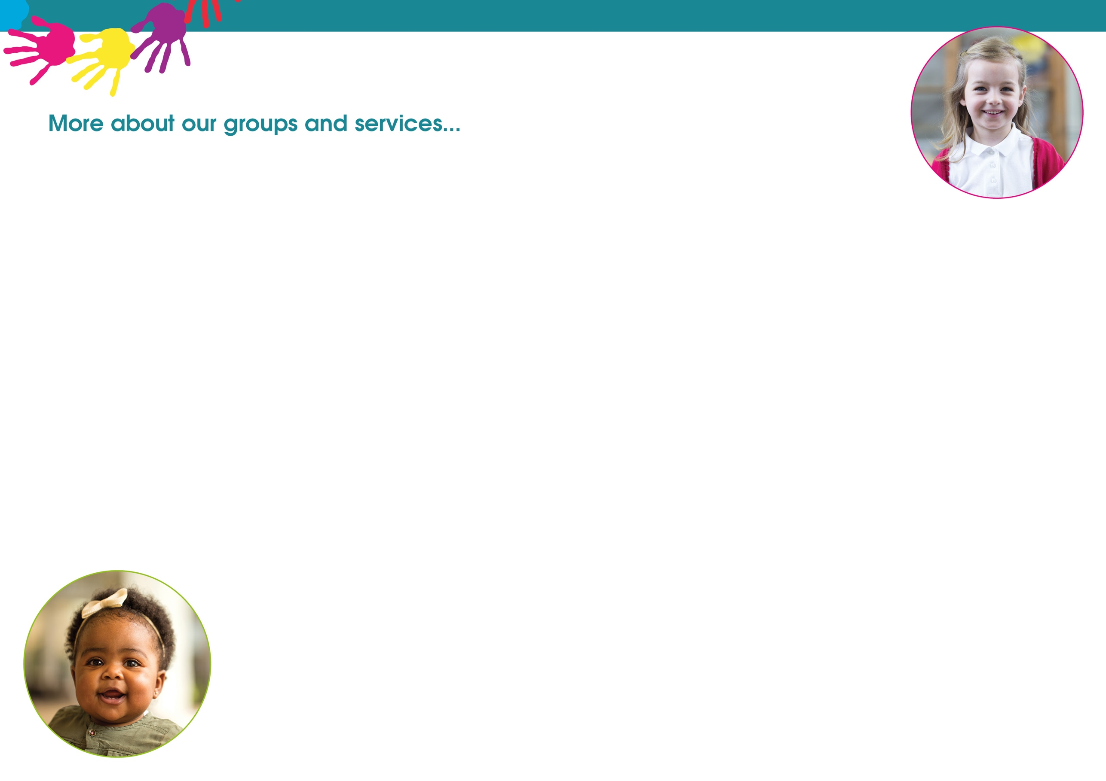

Youth Group (12-19yrs): an opportunity for you to meet with the Neighbourhood Outreach Workers and discuss issues that are current and affecting your lives. A chance to discuss and learn about the issues that affect young people like bullying, low self-esteem, drugs, relationships, sexual health and child sexual exploitation. Aimed at young people that would like to know more information on specific issues and become more involved with a youth group.

Youth Council
Youth Council is an opportunity for young people 12-19 to have a voice and be able to influence decisions made locally and nationally. Regular meetings in districts give young people the opportunity to be involved in projects and campaigns that they identify as significant to them and others.

7up Junior Group (8-11yrs): an opportunity to take part in a variety of games and activities to help to build confidence and self-esteem and set boundaries. Meet with other young people and discuss the issues that they might find themselves struggling with.

Nurture group
A Group aimed at 8-11year olds to help develop their emotional wellbeing and self-confidence. There will be a range of fun and engaging activities promoting confidence skills as well as tools to cope with their emotions and building their self-esteem.

