1.  Fabulous Fractions!    Complete the fraction sheet in your homework book. | 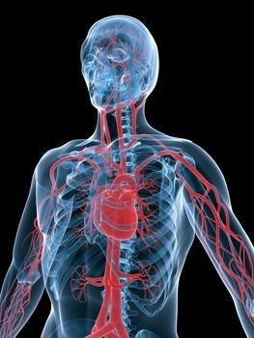  Year 6 Homework  Spring Term 2 |  | 2. Design a menu aimed at children who want to eat healthier. Keep it interesting and varied so that children will be more likely to stick to the foods you suggest.
3.  Make your own model of the heart. 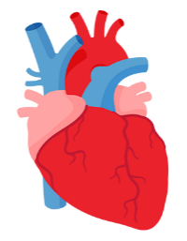 | 4.  Design a poster or a leaflet encouraging families to spend more time together outside and exercising. Remember exercising can be taking the dogs for a walk or a run around the park. Don’t forget to include why it would be good for them. | 5.  Write down the food you have eaten over one day. Use the Internet to find out how many calories you have eaten that day. Is it higher or lower than what you should have?   | 6.  Look at ways in which people can stay active in Preston. Using the internet or leaflets from leisure centres to gather information, list 5 ways adults can keep active and 5 ways in which children can keep active.
7.  Create a poster of the circulatory system and label the different parts. | 8.  Create a model of the lungs – think about what materials would be best to use.  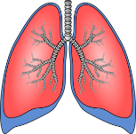 | 9.  Create an information poster persuading adults in Preston to donate blood. Think about the benefits and why it might be a good thing to do. | 10.  Create a fact file about the circulatory system
As well as the above, the following homework should be done every week:
- Times tables – by the end of year 4, it is expected that all children know all their times tables up to x12.
You have all been given a log in for Times Tables Rockstars – please use it at home to practise – the competition is on. www.ttrockstars.com
- Spellings – given weekly. The statutory spellings are on the class web page.
The following website will help you to learn and practise your spellings www.spellingframe.co.uk
- Reading – this can be your home/ school reader, a library book, a magazine or comic or something else that you enjoy reading. Keep reading – it will also help you with your writing.

