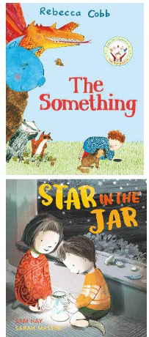
Core Units Ready Steady Write Books
Year Group | Book Title | Author | Cover Image | ISBN
EYFS | The Something | Rebecca Cobb |  | 9781529017519
EYFS | Star in a Jar | Sam Hay |  | 9781405284301
EYFS | Juniper Jupiter | Lizzy Stewart | 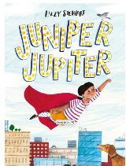 | 9781786037015
EYFS | Little Red | Bethan Woolvin | 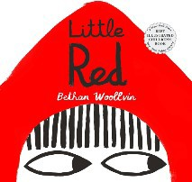 | 9781561459179
EYFS | The Extraordinary Gardener | Sam Boughton | 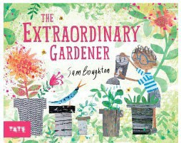 | 9781849766890

EYFS | The Storm Whale | Benji Davies | 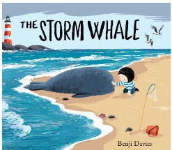 | 9781471115684
Year 1 | Old Bear | Jane Hissey | 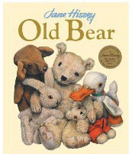 | 9781800787599
Year 1 | Rapunzel | Bethan Woolvin | 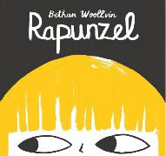 | 9781682630037
Year 1 | Hermelin | Mini Grey | 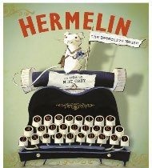 | 9781849415620
Year 1 | Where the Wild Things Are | Maurice Sendak | 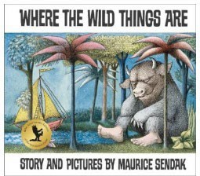 | 9780099408390
Year 1 | The Secret of Black Rock | Joe Stanton | 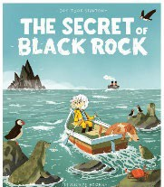 | 9781911171744

Year 1 | The Last Wolf | Mini Grey | 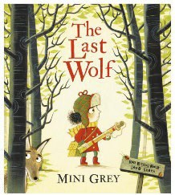 | 9781849419826
Year 2 | A River | Marc Martin | 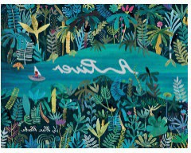 | 9781783704330
Year 2 | The Night Gardener | The Fan Brothers | 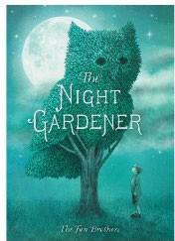 | 9781786030412
Year 2 | The Bog Baby | Jeanie Willis | 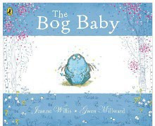 | 9780141500300
Year 2 | Grandad’s Island | Benji Davies | 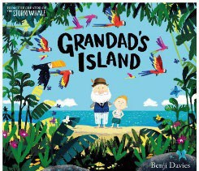 | 9781471119958
Year 2 | The King who Banned the Dark | Emily-Haworth-Booth | 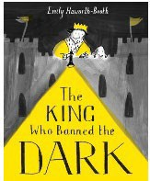 | 9781843653974

Year 2 | Rosie Revere, Engineer | Andrea Beaty | 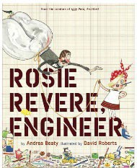 | 9781419784088
Year 3 | The Iron Man | Ted Hughes (Chris Mould edition) | 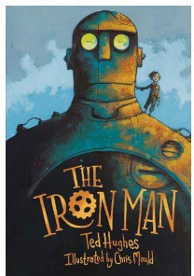 | 9780571348862
Year 3 | Fox | Margaret Wild | 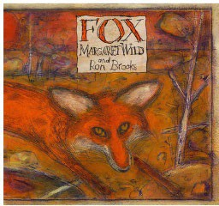 | 9781864489330
Year 3 | The Rhythm of the Rain | Grahame Baker Smith | 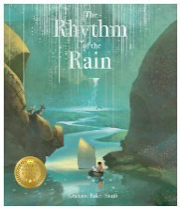
Year 3 | The Visible Sounds | Yin Jianling | 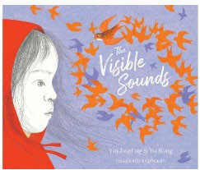 | 9781912979790

Year 3 | Egyptology | Ian Andrew | 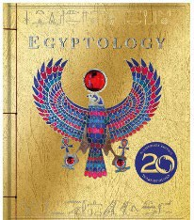 | 9781840118520
Year 3 | Into the Forest | Anthony Browne | 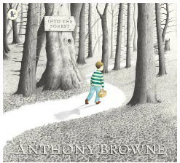 | 9781844285594
Year 4 | The Whale | Vita Murrow | 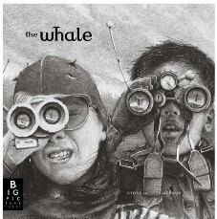 | 9781783701711
Year 4 | Leaf | Sandra Dieckmann | 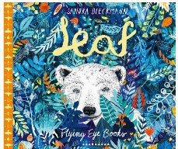 | 9781911171737
Year 4 | Arthur and the Golden Rope | Joe Stanton | 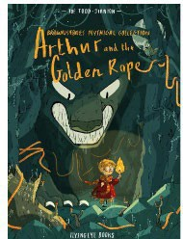 | 9781911171690

Year 4 | The Lost Happy Endings | Carol Ann Duffy | 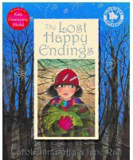 | 9780747581062
Year 4 | The Journey | Francesca Sanna | 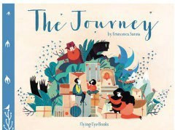 | 9781911171348
Year 4 | Manﬁsh | Jennifer Berne | 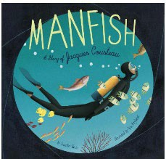 | 9781452141237
Year 5 | When we Walked on the Moon | David Long | 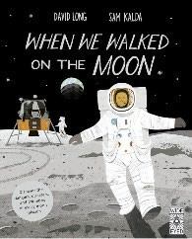 | 9781786030924
Year 5 | FArTHER | Grahame Baker Smith | 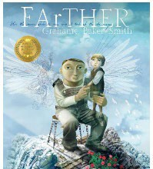 | 9781848771338

Year 5 | The Hound of the Baskervilles- Graphic Novel | Daniel Ferran & Oxford Children’s Classics | 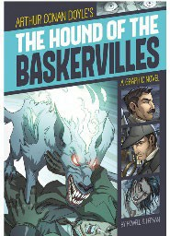 | 9781496500359
Year 5 | The Promise | Nicola Davies | 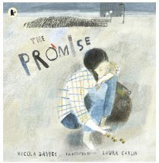 | 9781406355598
Year 5 | The Lost Book of Adventure | (compiled by) Teddy Keen | 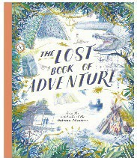 | 9781786032966
Year 5 | King Kong | Anthony Browne | 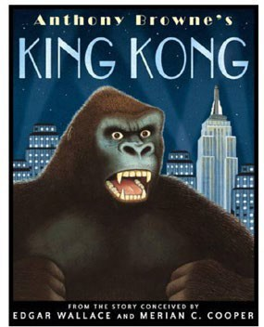 | 9780552553841
Year 6 | Rose Blanche | Christophe Gallaz & Roberto Innocenti | 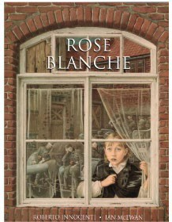 | 9780224028417

Year 6 | Anne Frank | Josephine Poole & Angela Barrett | 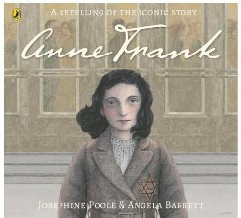 | 9780099409762
Year 6 | A Story Like the Wind | Gill Lewis | 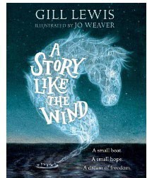 | 9780192758958
Year 6 | The Origin of the Species | Sabina Radeva | 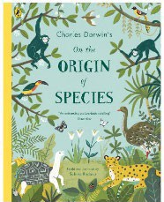 | 9780141388519
Year 6 | Darwin: An Exceptional Voyage | Fabien Grolleau | 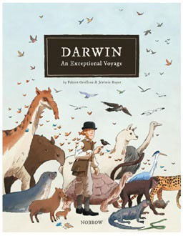 | 9781910620502
Year 6 | The Ways of the Wolf | Smriti Prasadam-Halls |  | 9781526360304

Year 6 | Shackleton’s Journey | William Grill | 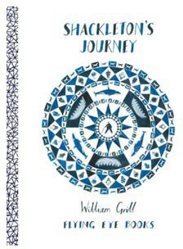 | 9781909263109
Year 6 | Hansel & Gretel | Neil Gaiman | 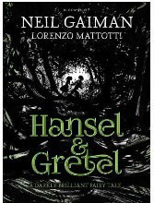 | 9781408861981

Ready Steady Write PLUS+ Book List
Collection Name | Year Group | Book Title | Author | Cover Image | ISBN
Shakespeare Collection | Year 3-6 | A Stage Full of Shakespeare Stories | Angel McAllister | 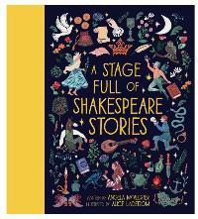 | 9781786031143
Olympic Collection | EYFS | Ready Steady Mo | Mo Farah & Kes Gray | 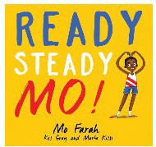 | 9781444934076
Olympic Collection | Year 1 | Splash | Claire Cashmore | 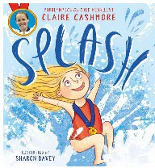 | 9780755502851

Olympic Collection | Year 2 | Sportopedia | Adam Skinner | 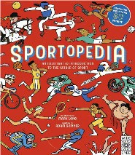 | 9781786030856
Olympic Collection | Year 3 | Usain Bolt:Little People, Big Dreams | Maria Isavel Sanchez Vegara | 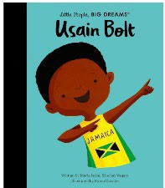 | 9780711291973
Olympic Collection | Year 4 | The Corinthian Girl: Champion Athlete of Ancient Olympia | Christine Balit | 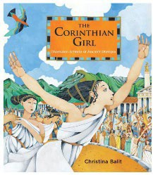 | 9781913074722
Olympic Collection | Year 5 | Long-Armed Ludy and the First Woman's Olympics | Jean L S. Patrick |  | 9781580895460
Olympic Collection | Year 6 | Stories for Boys Who Dare to be Different 2 | Ben Brooks | 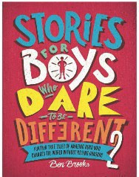 | 9781787476554

Olympic Collection | Year 6 | Goodnight Stories for Rebel Girls 2 | Elena Favilli | 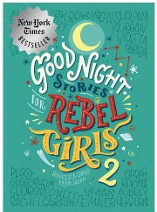 | 9780997895827
Environment Collection | EYFS | Saving Mr Hoot | Helen Stephens | 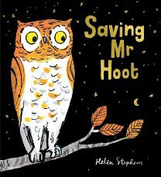 | 9781407191973
Environment Collection | Year 1 | Last Tree in the City | Peter Carnavas | 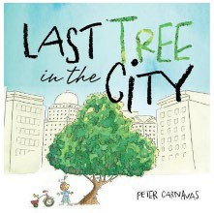 | 9781912076499
Environment Collection | Year 2 | Tidy | Emily Gravett | 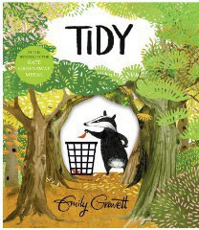 | 9781447273998
Environment Collection | Year 3 | Dear Earth | Isobel Otter | 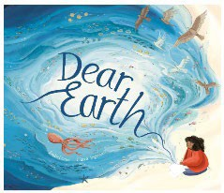 | 9781838911706

Environment Collection | Year 4 | The Secret Sky Garden | Linda Sarah | 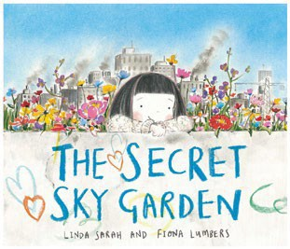 | 9781471119262
Environment Collection | Year 5 | Greta and the Giants | Zoë Tucker | 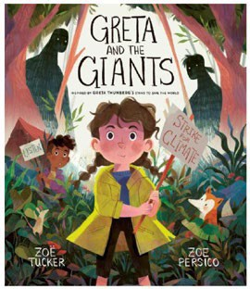 | 9780711253759
Environment Collection | Year 6 | Varmints | Helen Ward | 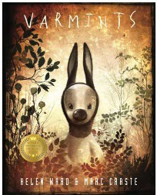 | 9781848775053
Science Collection | EYFS | The River | Tom Percival | 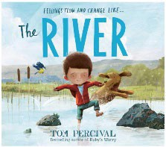 | 9781471191329
Science Collection | Year 1 | The Adventures of Egg Box Dragon | Richard Adams | 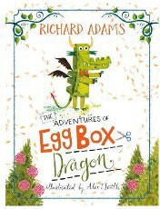 | 9781444938401
Science Collection | Year 2 | Bloom | Anne Booth | 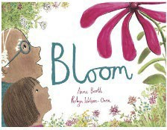 | 9781910328446

Science Collection | Year 3 | Wisp | Zana Fraillon | 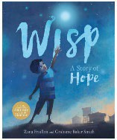 | 9781408350119
Science Collection | Year 4 | The Great Kapok Tree | Lynne Cherry | 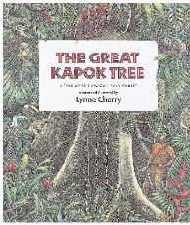 | 9780152026141
Science Collection | Year 5 | Wild is the Wind | Grahame Baker- Smith | 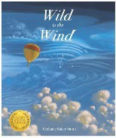 | 9781787416864
Science Collection | Year 6 | Rise Up | Amanda Li | 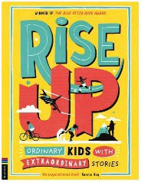 | 9781916763227
Additional Collection | EYFS | Mr Gumpy’s Outing | John Burningham | 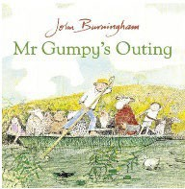 | 9780099408796
Additional Collection | Year 1 | There’s a Tiger in the Garden | Lizzy Stewart | 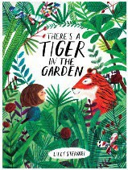 | 9781847808073

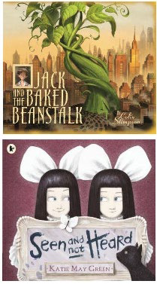
Additional Collection | Year 2 | Jack and the Baked Beanstalk | Colin Stimpson |  | 9781848772373
Additional Collection | Year 3 | Seen and Not Heard | Katie May Green |  | 9781406360998
Additional Collection | Year 4 | Leon and the Place Between | Angela McAllister | 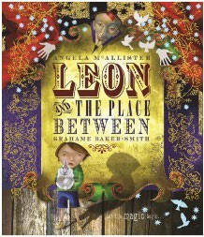 | 9781840118605
Additional Collection | Year 5 | Henry’s Freedom Box | Ellen Levine | 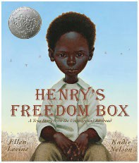 | 9780439777339
Additional Collection | Year 6 | Paradise Sands | Levi Pinfold | 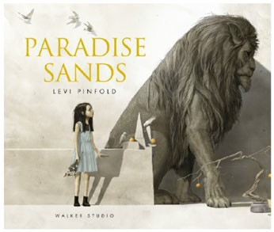 | 9781529520040

Core
Units Ready Steady Write Books:
EYFS
- The Something by Rebecca Cobb
- Star in a Jar by Sam Hay
- Juniper Jupiter by Lizzy Stewart
- Little Red by Bethan Woolvin
- The Extraordinary Gardener by Sam Boughton
- The Storm Whale by Benji Davies
Year 1
- Old Bear by Jane Hissey
- Rapunzel by Bethan Woolvin
- Hermelin by Mini Grey
- Where the Wild Things Are by Maurice Sendak
- The Secret of Black Rock by Joe Stanton
- The Last Wolf by Mini Grey
Year 2
- A River by Marc Martin
- The Night Gardener by the Fan Brothers
- The Bog Baby by Jeanie Willis
- Grandad’s Island by Benji Davies
- The King who Banned the Dark by Emily Haworth-Booth
- Rosie Revere, Engineer by Andrea Beaty

Year 4

Year 5

Year 6

- The Iron Man by Ted Hughes (Chris Mould edition)
- Fox by Margaret Wild
- The Rhythm of the Rain by Grahame Baker Smith
- Jemmy Button by Alix Barzelay
- Egyptology by Ian Andrew
- Into the Forest by Anthony Browne

- The Whale by Vita Murrow
- Leaf by Sandra Dieckmann
- Arthur and the Golden Rope by Joe Stanton
- The Lost Happy Endings by Carol Ann Duffy
- The Journey by Francesca Sanna
- Manﬁsh by Jennifer Berne

- When we Walked on the Moon by David Long
- FArTHER by Grahame Baker Smith
- The Hound of the Baskervilles - Graphic Novel by Daniel Ferran & Oxford Children's Classics: The Hound of the Baskervilles
- The Promise by Nicola Davies
- The Lost Book of Adventure compiled by Teddy Keen
- King Kong by Anthony Browne

Year 3

  - Rose Blanche by Christophe Gallaz and Roberto Innocenti & Anne Frank by Josephine Poole and Angela Barrett
  - A Story Like the Wind by Gill Lewis
  - The Origin of the Species Sabina Radeva & Darwin Novel by Fabien Grolleau
  - The Ways of the Wolf by Smriti Prasadam-Halls & The Wolves in the Walls by Neil Gaiman
  - Shackleton’s Journey by William Grill
  - Hansel & Gretel by Neil Gaiman
Ready Steady Write PLUS+ Book List:
Shakespeare Collection:
Year 3 – 6: A Stage Full of Shakespeare Stories by Angela McAllister
Olympic Collection:
- EYFS - Ready Steady Mo by Mo Farah and Kes Gray
- Y1 - Splash by Claire Cashmore
- Y2 - Sportopedia by Adam Skinner
- Y3 -Little People Big Dreams Usain Bolt (available to pre- order released on June 6th)
- Y4 - The Corinthian Girl: Champion Athlete of Ancient Olympia by Christina Balit
- Y5 - Long-Armed Ludy and the First Woman's Olympics by Jean L S. Patrick
- Y6 - Stories for Boys Who Dare to be Different 2 by Ben Brooks & Goodnight Stories for Rebel Girls 2 by Elena Favilli
Environment Collection:
- EYFS – Saving Mr Hoot by Helen Stephens
- Y1 – Last Tree in the City by Peter Carnavas
- Y2 – Tidy by Emily Gravett
- Y3 – Dear Earth by Isobel Otter
- Y4 – The Secret Sky Garden by Linda Sarah
- Y5 – Greta and the Giants by Zoë Tucker
- Y6 – Varmints by Helen Ward
Science Collection:
- EYFS – The River by Tom Percival
- Y1 – The Adventures of Egg Box Dragon by Richard Adams
- Y2 – Bloom by Anne Booth
- Y3 – Wisp by Zana Fraillon
- Y4 – The Great Kapok Tree by Lynne Cherry
- Y5 – Wild is the Wind by Grahame Baker-Smith
- Y6 – Rise Up by Amanda Li
Additional Collection:
- EYFS – Mr Gumpy’s Outing by John Burningham
- Y1 – There’s a Tiger in the Garden by Lizzy Stewart
- Y2 – Jack and the Baked Beanstalk by Colin Stimpson
- Y3 – Seen and Not Heard by Katie May Green
- Y4 – Leon and the Place Between by Angela McAllister
- Y5 – Henry’s Freedom Box by Ellen Levine
- Y6 – Paradise Sands by Levi Pinfold

Ready Steady Write 2026 Unit Releases
Year Group | Book Title | Author | Cover Image | ISBN
EYFS | Ning and the Night Spirits | Adriena Fong | 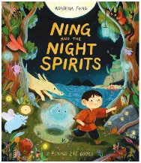 | 9781838743574
EYFS | Mixed | Arree Chung | 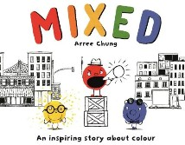 | 9781509871346
EYFS | There’s a Tiger on the Train | Mariesa Dulak | 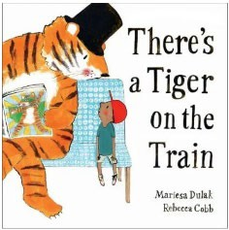 | 9780571368341
Year 1 | The Girl at the Front of the Class | Onjali Q. Raύf | 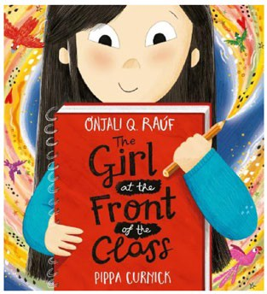 | 9781526364661
Year 1 | The Boy with Flowers in His Hair | Jarvis | 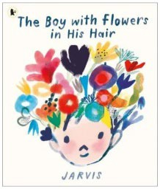 | 9781529506761
Year 1 | The Queen Next Door | Marcela Ferreira | 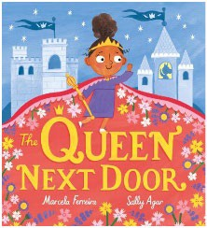 | 9781408366134

Year 1 | Cloud Boy | Greg Stobbs | 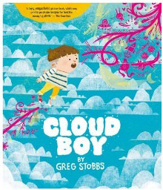 | 9781382054904
Year 2 | Leo and the Octopus | Isabelle Marinov | 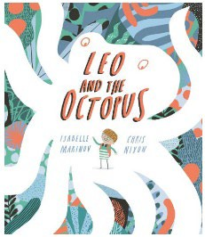 | 9781787416550
Year 2 | Grandad’s Camper | Harry Woodgate |  | 9781783449927
Year 2 | The Misadventures of Frederick | Ben Manley | 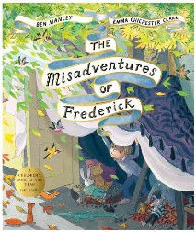 | 9781509851546
Year 3 | Ocean Meets Sky | The Fan Brothers | 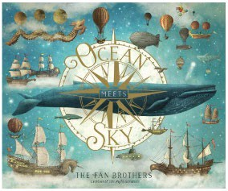 | 9781786035622

Year 3 | The Forgettery | Rachel Ip | 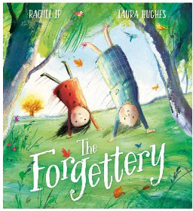 | 9781405294768
Year 3 | It Fell from the Sky | Devin Fan | 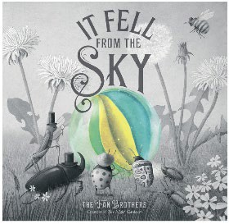 | 9780711270664
Year 4 | Nen and the Lonely Fisherman | Ian Eagleton | 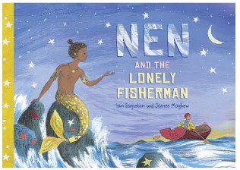 | 9781913339098
Year 4 | The Boy Who Grew Flowers | Jen Wojtowicz | 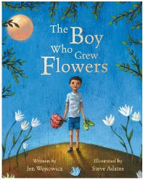 | 9781846867491
Year 5 | Curiosity- The Story of a Mars Rover | Markus Motum | 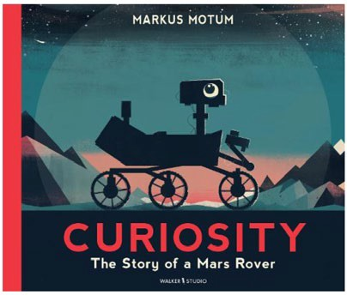 | 9781529517378

Year 5 | Milo Imagines the World | Matt de la Peña | 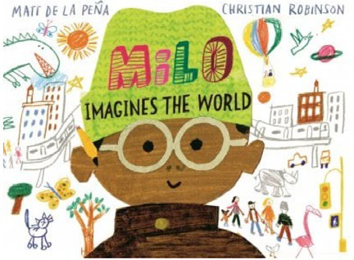 | 9781529066326
Year 6 | Rescuing Titanic | Flora Delargy | 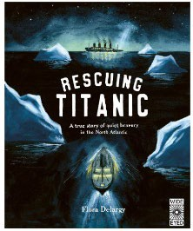 | 9781836007579
Year 6 | The Lost Book of Undersea Adventure | Teddy Keen/ Unknown Adventurer | 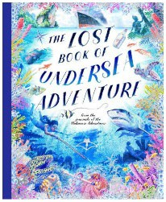 | 9780711296763
Year 6 | Station Cat | Stephen Hogtun | 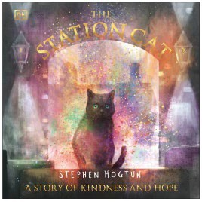 | 9780241625927

