

Ribbleton Avenue Methodist Junior School
Geography Action Plan (2025-2026)
“Brighter futures built with Ambition, Courage and Respect; filled with Love, Hope and Faith.”

Responsibility Area: Geography |  |  | Lead: Miss L Parkinson |  | Link Governor: TBC
Aims/Targets:

- To ensure that children can develop their geography skills as well as their knowledge
- To ensure that fieldwork is evident across all year groups
- To continue to monitor how geography is assessed within school and to ensure staff are confident in this area
- To develop use of technology to enrich experiential learning
- To continue to develop links between outdoor education provision and geography
- To ensure trips are being used as an opportunity for geography learning
- To ensure pupils are building on their skills from the previous year and that they can demonstrate their learning in a variety of ways
- To ensure that writing at length, appropriate to age, is evident in the geography curriculum

National Curriculum Focus for 2025-26

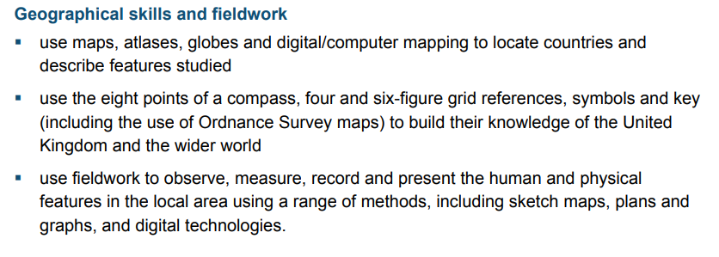

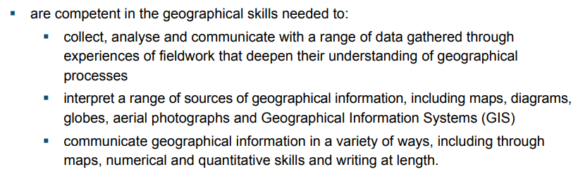

Autumn milestones  - To audit resources and share information on digimaps  - To develop opportunities for experiential learning |  | Spring milestones  - To discuss links between outdoor education and geography  - To ensure that school trips are being used as geography learning opportunities |  |  |  | Summer milestones  - To ensure that writing in length is happening across all year groups  - To ensure key concepts from previous learning/stages are covered  - To ensure staff use knowledge pages
Year 1
Action | By Whom | By When |  | Success Criteria |  | Evidence | Evaluation
Audit resources and order resources needed to effectively teach the new curriculum, ensure new resources are utilised. | L Parkinson  Teachers | On-going throughout the year |  | Teachers will have resources that they require to effectively teach their new topics.  Teachers will be shown how to use digimaps and will be encouraged to utilise this resource. |  | Central location where resources are kept for staff to access  Learning walks
To continue developing links between outdoor education and geography | L Parkinson  A Moran  P Langfield  N Pidcock (orienteering) | On-going throughout the year |  | Making links will have a positive impact on pupil learning by reinforcing geography skills across within the wider curriculum such as how to use a compass, map work and orienteering |  | Pupils will have developed their geography skills and knowledge to a greater extent (evidence through books, photographs and conversations with pupils).
To ensure that key geography objectives are being covered and all classes are producing ‘writing at length’ pieces which are relevant / age expectancy. | L Parkinson  Teachers | On-going throughout the year |  | By the end of KS2, all pupils will have been provided with a well-rounded geography curriculum which has allowed them to learn about a variety of geographical topics and develop their skills, especially fieldwork skills.  Children have been given opportunities to ‘write at length’ ideally once a topic. |  | Pupils will be able to demonstrate their geographical skills in a variety of contexts and will be able to apply their learning.  Children’s learning in books.
To ensure that key concepts from previous years / previous key stages are revisited | L Parkinson  Teachers | On-going throughout the year |  | Pupils will have the opportunity to continuously build on their skills and knowledge in all areas of the geography curriculum  Sticky learning principles will be used- starter questions etc. |  | Work in books  Topic plans  Coverage matrix  Learning walks
To ensure staff assess children using ‘knowledge pages’ at the end of a topic which allow pupils to show what they have learnt | L Parkinson | On-going throughout the year |  | Teachers will use knowledge pages to assess the topic-based knowledge of the children (these can be in a variety of formats e.g. posters, adobe express, non-chronological reports etc.) |  | Knowledge pages in books
To develop opportunities for experiential learning utilising VR headset | L Parkinson  Teachers | On-going throughout the year |  | All pupils can demonstrate practical geography skills in a variety of ways  All children will get to experience geography through the VR headsets throughout the year. I will share pre-made VR playlists with staff. |  | Photos
To ensure that school trips are being used as geography learning opportunities | L Parkinson  Teachers | On-going throughout the year |  | All staff are encouraging pupils to use their geography skills outside of school  All staff are using school trips as a learning opportunity for pupils to build on their geography skills  Ensure all staff know which geography objectives to focus on where relevant for trips (curriculum objectives to hand.) Ensure sketch maps used across all years. |  | Pupils’ work  Photos

