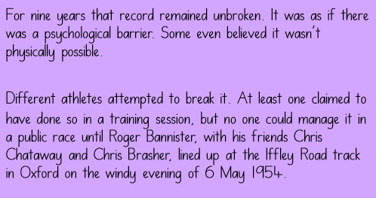
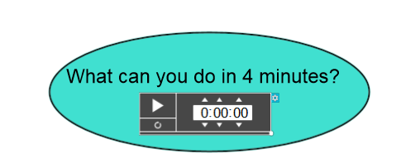
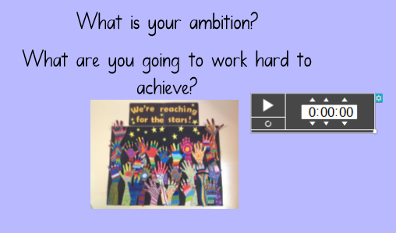
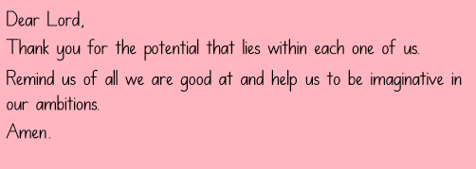

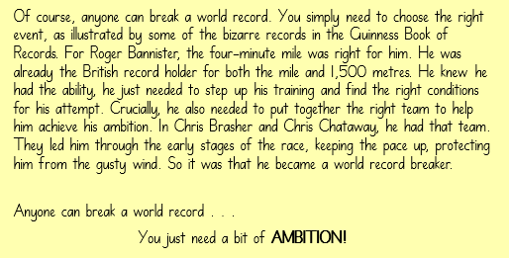
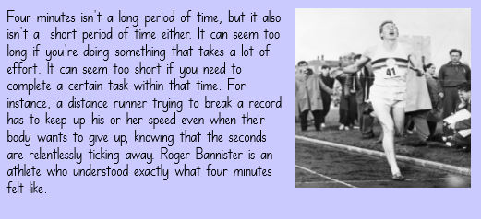
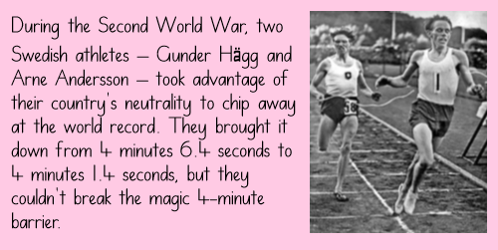
4R children (Raafayh, Aiysha, Brayden and Remayah) led class worship on the theme of Ambition. They challenged their class using questions to encourage discussion and reflection. They decided they could do allsorts in 4 minutes, including learning their spellings or sharing a prayer. Their friends shared some of their aspirations for the future including becoming a famous Hip Hop dancer or a pilot.

