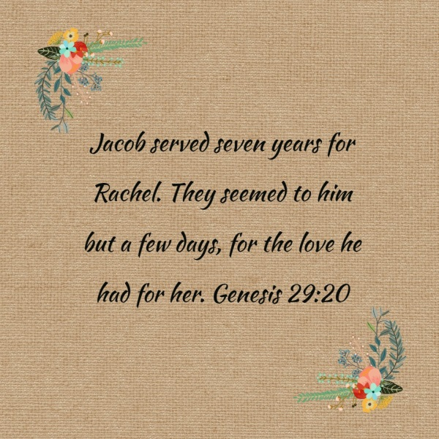
RESPECT
The girls led a worship session in their class based on Respect.







They asked really thought provoking questions and challenged their peers to consider:
- Who should be respected?
- Why we should respect others?
- How can we show respect?

Using the story of Rachel and Jacob, the girls talked about how Jacob served 7 years working for her father in a hope that he could marry Rachel. He was tricked by her father and Jacob was given Rachel’s sister Leah instead. Jacob worked another 7 years to marry Rachel. Leah knew that Jacob had wanted to marry Rachel not her and this made Leah sad. God came to her and blessed her with a child. This made Leah realise that it didn’t matter if Jacob preferred Rachel for Leah was kind and caring and God has recognised in her these qualities.
The girls used this story to talk about how this must have felt for all the characters and considered Respect throughout the story linking the respect the women were shown. They asked who got the most respect and why and who should have been given the most respect?

