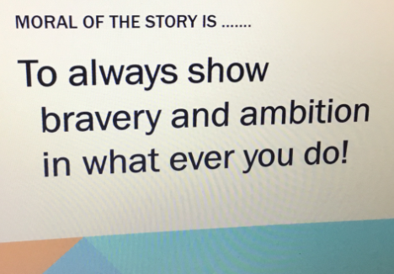
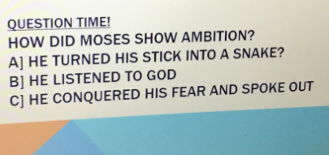
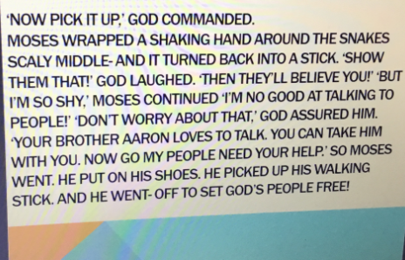
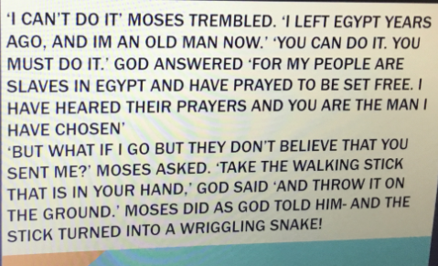
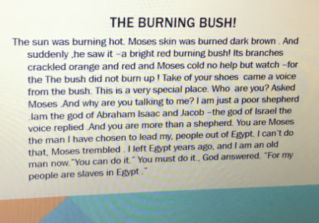
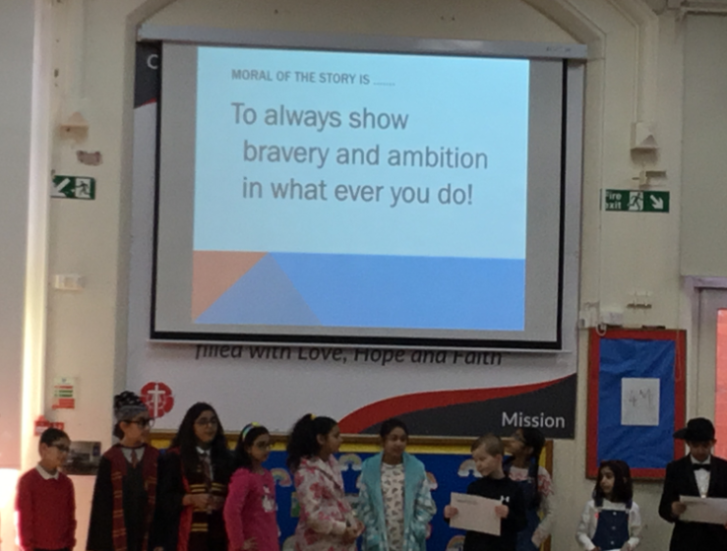
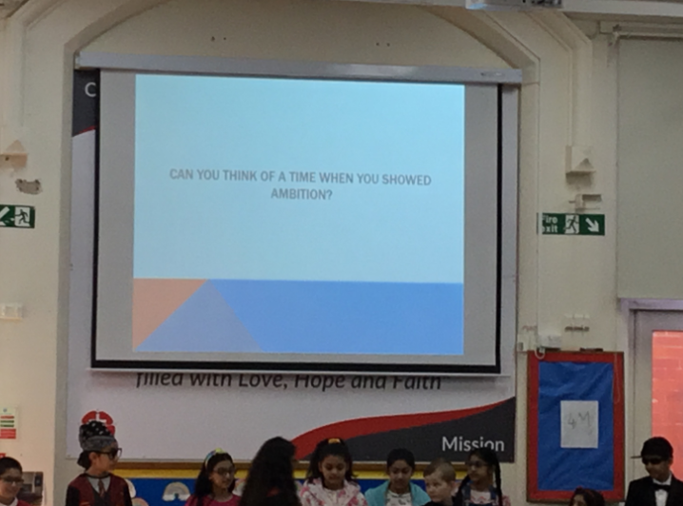
Our ambitions
“I want to be a F1 driver”
“I want to be an artist”
“I want to be happy!”
Mrs Penrith (Governor)
“Well done, the children led worship really well and it was thoroughly enjoyable. There was lots of interaction and it linked well with our school values. They came into the hall and left singing beautifully. I was really impressed!”
Ambition

